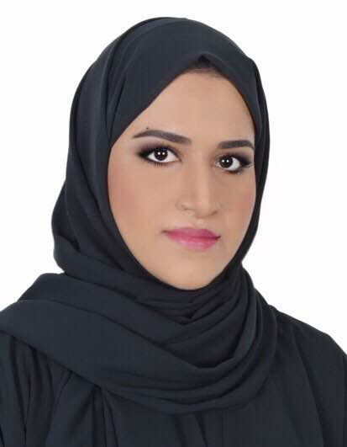**AMNA SULTAN SALEM Al-BANKI**

Address: **Bu Kowarah, Riffa**

**P.O. Box 28059**

**Kingdom of Bahrain**

Mobile: **+973-38803990**

Email: **amnaalbanki93@gmail.com**

**PERSONAL DETAILS**

Date of Birth: 24th August 1993

Sex: Female

Nationality: Bahraini

Marital Status: Single

CPR: 930809238

**EDUCATIONAL ATTAINMENT**

**Bahrain Polytechnic University**

Bachelor of Web Media - Graduated 2015 (3.10 GPA)

* *Courses include*: English for the Web, Website Programming, Mobile Website Development, Web Design, 3D Modeling & Animation, Multimedia Technology, Videography, Photography, Strategic Web Communication & Content Creation, Content Management, eMarketing, eBusiness, Human Computer Interaction.

**Modern Knowledge Schools (MKS)**

High School (American Diploma) - Graduated 2010 (92% - 3.64 GPA)

**WORK EXPERIENCE**

**SHURA COUNCIL**

*Multimedia Specialist*

September 2018 – May 2019

Responsibilities include:

* Develop titles and motion graphics using software programs such as Adobe After Effects and Photoshop.
* Editing high quality videos using Adobe Premiere.
* Assisting in designing website page layouts using Adobe Photoshop.

**WNNA (Startup) /** https://www.wnna.co

*Creative Designer*

Amwaj, Bahrain

February 2018 – May 2018

Responsibilities include:

* Producing design concepts and assist with prototype development
* Presenting concept visualizations through sketches and designs
* Overseeing design changes and improvements
* Create visual aspects of marketing materials and other media
* Ensure consistency of brand identity
* Integrating technical and visual solutions into a design concept
* Understanding trends within the scope of the industry

**4SPOTS (Digital Agency) /** https://www.4spots.com

*Designer/Social Media Executive*

Amwaj, Bahrain

August 2016 - February 2017

Responsibilities include:

* Designing and creating artworks for Social Media networks
* Branding artworks, designing and creating branding templates
* Creating Social Media content

**BAPCO /** http://www.bapco.net

*IT Trainee*

Awali, Bahrain

September 2015 – February 2016

Responsibilities include:

* Working and completing tasks on SharePoint.

**CERTIFICATIONS**

**Professional Diploma in Digital Marketing (DMI – Digital Marketing Institute)**

ProCloud Bahrain - https://www.procloud.bh

September 2017

**ADDITIONAL SKILLS:**

* Excellent computer skills: Adobe Photoshop, Adobe Illustrator, Adobe Dreamweaver, Adobe After Effects, Adobe Premiere Pro, SharePoint, MS Office.
* Excellent verbal communication skills.
* Work confidently within a team/group.
* Determination to get things done. Consistently looking for better ways of doing things.
* Computer Savvy
* Manage time effectively, prioritizing tasks and able to work to deadlines.
* Spoken languages – fluent in Arabic and English.
* Key strengths – communication, problem solving, critical thinking, analytical abilities, attention to details, quick learner.
* Other interests: design, photography, art and sports.