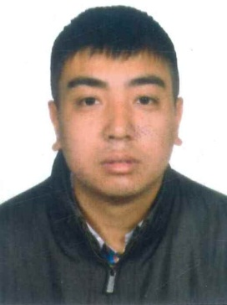**AVINESH PRADHAN**

Address: Hama town, Runabout10, Road: 426, House: 1461,Phone: +973-35059267 Email:aviprq@gmail.com

**OBJECTIVE**

Seeking an opportunity to acquire knowledge, the right skill set and capabilities which

Will help me become a good professional with a difference, and can identify

Opportunities in difficult circumstances as well where I can utilize my skills, abilities

In the field that offers professional growth being resourceful, innovative

**EXPERIENCE**

From 1st February 2011 to 10th April 2014

CASHIER, KUMAI STUDIO.

From 1st Jan 2019 to 5th Feburary2019

SALES MAN, MAHMOOD A.A.QADEER

FROM 10th March 2019 TO STILL WORKING

SALES MAN, ALMUNTAZAH SUPERMARKET

I am working as sales man .I have good knowledge about display.

I have also good experience about cashier.

**EDUCATION**

PASSING YEAR 2012

JNANESHWAR MEMORIAL ACADEMY

Passing from I.C.S.E Board with 64%

PASSING YEAR 2013

HOLY CROSS INSTITUTE KURSEONG

Passing from Commerce group and secured 56.65%

B.COM DEGREE TWO AND HALF YEAR

FROM ST JOSEPH COLLEGE NORTH POINT DARJEELING

**SKILLS**

Good Communication Skills Excellent in Gaining Commitments

Adapting the use of MS Word and Excel Effective Cold Calling strategies

**ACTIVITIES**

Hobbies include Travelling, Net Surfing and very well playing cricket etc.

**PERSONAL INFORMATION**

FATHER NAME: ASHOK PRADHAN

MOTHER NAME: MANIKALA PRADHAN

CITIZENSHIP: INDIAN

SEX: MALE

RELIGION: IHINDU

LANGUAGE: ENGLISH, NEPALI, HINDI

CPR NO: 96O830901

PASSPORT NO: S0014117

DATE OF BIRTH: 5TH AUGUST 1996

**DECLARATION**

I hereby declare that the above mention are true to the best of my knowledge and believe

AVINESH PRADHAN