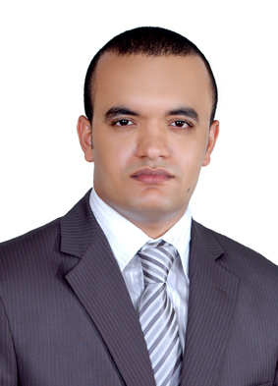

###### **Ahmed Ahmed Ibrahim Ahmed El-Desouky.**

Budayia - Kingdom of Bahrain

+973 33161013

a.desoki88@gmail.com

# ـــــــــــــــــــــــــــــــــــــــــــــــــــــــــــــــــــــــــــــــــــــــــــــــــــــــــــــــــــــــــــــــــــــــــــــــــــــــــــــــــــــــــــــــــــــــــ

# Objective:

**Seeking new challenging position, educational and communication skills can be further enhanced within an active working environment.**

# Personal information:

- Birth date: 23/3/1988

- Nationality: Egyptian.

- Marital state: Single.

- Military state: Accomplished.

- GCC Driving license: valid.

- Own car: Available

EDUCATION:

* Graduated from **faculty of pharmacy in Cairo University 2010**.
* Overall grade: **Good**.

# WORK EXPERIENCE:

* Country Sales Supervisor at **Floxia Laboratories** , {10/2018-Present}.
* Product Specialist at **Imdad** **for Medical Devices,** {06/2018-10/2018}.
* Medical Representative at **Vichy Laboratories** ,L’Oreal Active Cosmetics Department {01/2015-12/2017}
* Pharmacist at **Makah Pharmacy**-West Riffa {12/2013-01/2015}
* Medical Representative at **Multi-Pharma Co**.(Ortho Line){from 1/2012-09/2013}
* Community Pharmacist at **Tanta Military Hospital** {from 12 / 2010 to 12 / 2011}.

Elective courses AND OTHER SKILLS:

* Core Skills of Effective Communication, HNI Training and Coaching, DUBAI.
  + - First Aid course in Faculty of Pharmacy-Cairo University.
    - English General Course from ALC.
    - Experience certificate in Armed forces pharmacies.
    - Very good using Microsoft Office (word, excel & power point) & internet application.

**Language:**

* English **Very Good**
* Arabic  **Mother tongue**

### Personal characters and skills:

Honest Persistence

Hard Worker Self-motivation

Ambitious Work under stress

REFERENCES:

Available upon request.