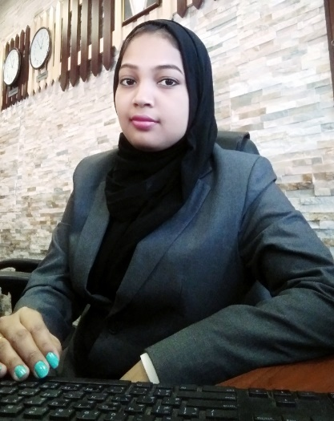CURRICULUM VITAE

Name: NAVISHA PARWEEN

Mobile: 66750108

Email**:** navishaparween1993@gmail.com

**POSITION APPLIED FOR: Receptionist / Assistant Accountant / Salesmen / Secretary**

**Responsibilities & Objective:**

* Handling guest & guest complaints also their request to making sure their pleasant stay
* Working as a receptionist cum cashier
* Highly organised and dedicated, with positive attitude
* Have excellent written, oral and interpersonal communication skills
* Speak and write Hind Arabic & English
* Able to handle multiple assignments under high pressure and consistently meet tight deadlines
* Coordinating with Housekeeping team to get ready the flat for guest checked in
* Handling invoices & quotations
* Placing order for guest amenities.
* Handling employees related grievances.
* Coordinating with maintenance team to get done the pending maintenances.
* Making daily cash report summary.
* Maintaining clean flats availability & strengthening to maintain high occupancy.

**Educational profile:**

Matriculation completed in the year 2009 from Scottish Public School Katihar Bihar Affiliated from CBSE Delhi, India.

Intermediate completed in the year 2011 from MJM Mahila College Katihar Bihar Affiliated from BSEB Patna, India.

Graduation in Sociology Honors completed in the year 2015 from MJM Mahila College Katihar Bihar Affiliated from BSEB Patna, India.

**Work Experiences:**

* Currently working in Montana Suites Building 622 Road 2408 Block 324 Juffair a unit of Seven Hills Property Management as a **Receptionist cum Cashier and Assistant Accountant from:** 20th August 2019 – Till Date.

**Personal Attributes:**

* **Be honest and trustworthy**
* **Be respectful**
* **Possess cultural awareness and sensitivity**
* **Be flexible**
* **Demonstrate sound work ethics**

**Personal detail:**

Date of Birth : 14-02-1994

Nationality : Indian

Religion : Muslim

Marital Status : Married

Passport No : N7943245

CPR No : 940226774

**Declaration**

I hereby declare that the above mentioned information is true to the best of my knowledge.

Place: Manama

**Navisha Parween**