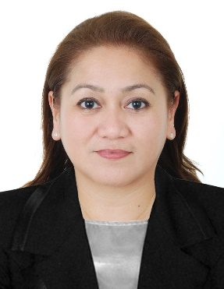**Maria Thelma Duma Teodosio** (LMT: 06-10-3677)

Villa 3466 Road 752 Maqabah 507

Kingdom of Bahrain

Mobile +973 34408217

E mail: [mariathelmaduma@gmail.com](mailto:mariathelmaduma@gmail.com)

**Job Objective**

To obtain an employment that will motivate me to maximize my extreme potential and in return avail of equally benefitting moral, social challenges, financial and personal rewards.

**Profile**

* Analytical and hardworking
* Flexibility to work
* Strong inter-personal skills
* Dedication to achieve a reputation for consistently pursuing beyond usual requirement

**Employment History:**

Name of Company **Etoile Salon and Spa**  
Period of Attendance June 2015 to Present

Position

* Massage Therapist
* Facialist
* Cashier

Name of Company **Edwin Samot Design and Spa**  
Period of Attendance May 2010 to August 2011

Position

* Massage Therapist

Name of Company **Nonbiri Salon and Spa**  
Period of Attendance January 2009 to April 2010

Position

* Massage Therapist
* Facialist

**TRAINING AND SEMINARS ATTENDED:**

**Bayanihan International Institute**  
Manama, Bahrain  
Caregiver  
July 2019 - Present  
  
**TESDA**

National Certificate II

For Massage and Therapy

May 7, 2010  
  
**TESDA National Capital Region Pamamarisan District**

Training Methodology 1 / Assessment Methodology 1

April 15 -21, 2010

**International NKYR Academy**

DOH Licensure Preparatory Course for Massage Therapist

June 29, 2010

**PERSONAL DATA**

Birth date: January 21, 1973

Birth Place: Pasay City

Height: 4. 11’

Weight: 55Kg

Status : Separated

Citizenship: Filipino

Religion: Muslim ( Reverted )

**EDUCATIONAL BACKGROUND:**

International NKYR Academy, Inc.

DOH-Licensure Preparatory Course for Massage Therapist

Cubao, Quezon City

March – June 2010

Imus Vocational and Technical School

Reflexology/Cosmetology

Imus, Cavite

May 2 – August5, 2008

SECONDARY:

Imus Institute

1985 – 1989

PRIMARY:

Bayan Luma II Elementary School

1979 – 1985

**Declaration**

I hereby declare that all above mention information is correct up to the best of my knowledge and I bear the responsibility for the correctness of the above mentioned particulars.

Thank you.

Place: Bahrain   
   
Date: **Maria Thelma Teodosio**