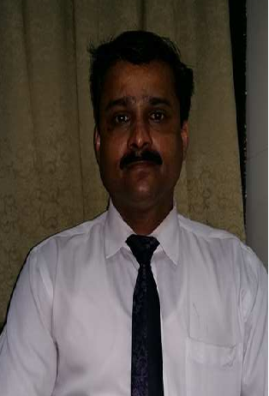

**ASHOK SAPALIGA**

**P O BOX 3280**

**MANAMA**

**KINGDOM OF BAHRAIN**

**mobile: 39526302**

[bulletashok26@gmail.com](mailto:bulletashok26@gmail.com)

**SUMMARY:**

Presentable and well motivated senior supervisor with over 4 years progressive experience with luxury hotels.

Possessing solid experience directing housekeeping teams, ensuring high quality cleanliness at all times, seeks varied position that will enable me to capitalize on my professional experience, with opportunities for personal growth.

**HIGHLIHTS:**

* Friendly with all Guests
* Effective time manager
* Deep cleaning expertise
* Efficient and accurate
* Hospitality back ground
* Decision making skills
* Self directed
* Physically able and strong
* Knowledge of floor polishing procedures

**EXPERIENCE:**

**Senior Housekeeping supervisor, November 2015 - current**

**Bahrain International Hotel**

**Manama**

* Direct reporting to Exe. House keeper
* Responsible to supervise the cleanliness and appearance the Hotel rooms and public area
* Supervising, preparing maintenance requirement for the guest rooms and public areas
* Inspect personally and supervise all the areas for the perfection of the given jobs
* Identify the requirements of linen and other equipments for the smooth functioning of the Department
* Monitoring and maintain the register and files like room check list, room occupancy file, log book, lost and found register, linen control and pest control file

**BAHRAIN AIRPORT SERVICE**

**Cleaning Supervisor**, **January 2001 to March 2006**

* To supervise and investigate the quality and standard of cleaning services
* To control and monitor the correct of appropriate cleaning materials and machines
* Proper checking all areas, porch, toilets, parking etc.

**RUWI APARTMENT, SULTANATE OF OMAN, March 2010 to December 2014**

**Cleaning and care taking**

* Cleaning the lobby and main area
* Floor scrubbing and polishing
* Floor buffing
* Carpet shampooing

**ACHIEVEMENTS:**

* Recognized as the outstanding employ of the year in 2004 (BAS)
* Recognized as the outstanding employ of the year in 2014 (RUWI)

**EDUCATION:**

* PUC NOT COMPLEATED
* S.S.L. C

**LANGUAGES KNOWN:**

English, Hindi, Kannada, Arabic, Malayalam

**PERSONAL INFORMATON:**

Date of Birth : 24/01/1978

Marital status : Married

Nationality : Indian

Passport number : J 7956281

C P R Number : 780140630

**REFERENCES:**

Personal Manager Bahrain International Hotel Manama, Kingdom of Bahrain

**DECLARATION:**

**I hereby declare that the above mentioned details are true to my knowledge and belief.**

**Ashok Sapaliga**