**CURRICULUM VITAE**

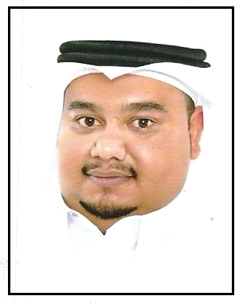

S.Mustafa Saeed Shubbar Hasan

**Personal details :**

**Birth Date:** 17/02/1989

**CPR Number:** 890208204

**Passport no:** 1933417

**Gender:** Male

**Nationality:** Bahraini

**Residence location:** Bahrain

**Marital Status:** Married

**Address:** Flat 1 – Building 665 – Road 4218 – Block 542 Diraz

**Contact no:**  +973 33325811/ +973 33081769

**Objectives:**

To find an interesting job in an organization where I would be able to train and use my communication skills, enhance my working ability and to contribute to the goals of the organization.

**Educational Qualifications:**

2009-2010 National Diploma 2 Bahrain Training Institute

2008-2009 National Diploma 1 Bahrain Training Institute

2007-2008 first Diploma Bahrain Training Institute

2003-2006 Secondary Certificate Sheikh Abdullah Industrial Secondary School

**Experiences**

25th Mar 2012 – 22th Nov 2012 Turk Mechanical Company (machine operator)

**Additional Skills:**

* Computer skills: windows office
* Driving license
* Languages: Arabic (mother language) - good in English and Indian