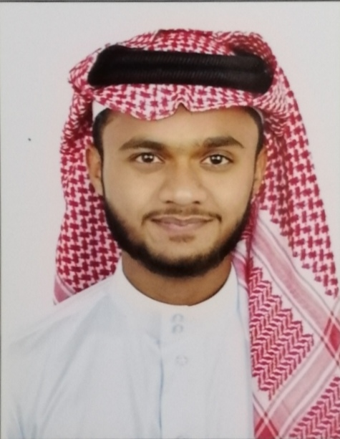



Contact

**Address:**

Muharraq , Kingdom of Bahrain

**Phone:**

+973 35618611

**Email:**

m.omer4110@gmail.com

Languages

English

Arabic

Urdu

Pashto

Hobbies

* **Cricket**(Best Bowler Of Under 16 Interschool Cricket tournament 2016)
* **Hockey**
* **Fishing**

Personal Information

Name : Mohamad Omer

Nationality : Bahraini

Date of birth : 4/11/2000

Sex : Male

Maritial Status : Single

Reliegion : Islam

Skill Highlights

|  |  |
| --- | --- |
| * Challenging * Strong decision maker * Complex problem solver | * Creative design * Innovative * Service-focused |

Experience

* **2 Years** experience as a **CHARITY COLLECTER**  at Islamic Society in Bahrain
* **Worked** as a **PROMOTER** in Lulu Hypermarket
* **Worked** as a **PROMOTER** for **STC**
* **Worked** as a **Exhibitor** in Exhibition of the Autum Fair 2020

Education

* S.S.C Completed from Ibn Al Haytham Islamic School (C.B.S.E BOARDS)
* H.S.C Graduated from Al-Hedaya Al-Khalifa Secondary Boys School
* Student of ACCA (Association of Chartered Certified Accountants)

MOHAMAD OMER