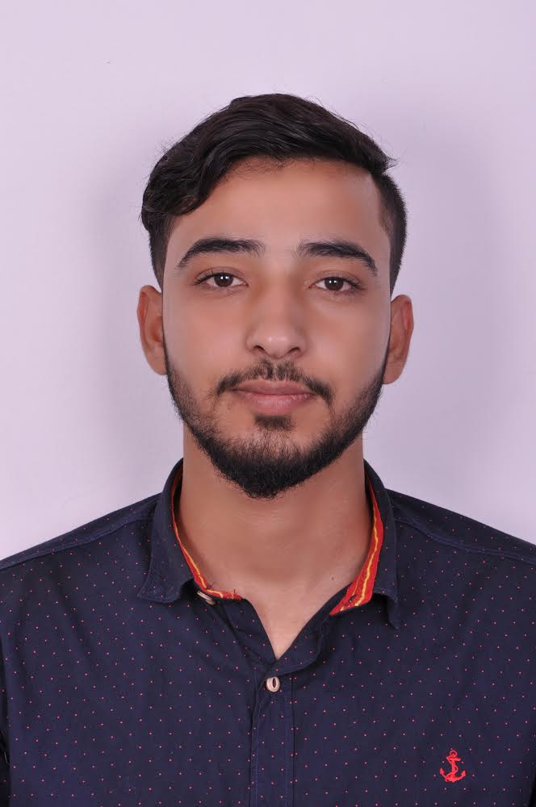

**Hafiz Muhammad Umar Khatab**

**Qudaibiya, Bahrain** • **Mobile: +97337241195** • **E-mail:** [**umarmehar901@gmail.com**](mailto:umarmehar901@gmail.com)

**PROFESSIONAL SUMMARY**

Experienced in salesmanship with over Two and half years in Bahrain . Excellent reputation for resolving problems, improving customer satisfaction, and driving overall operational improvements. Consistently saved costs while increasing profits.

**PERSONAL INFORMATION**

* **Nationality :** Pakistani
* **Personal Number :**  950828750
* **Date of Birth :**  18th August 1995
* **Gender :** Male
* **Marital Status :** Single
* **Driving license :** light vehicle 28/11/2018

**PROFESSIONAL EXPERIENCE**

**Sales representative** Mar 2018- Jun 2020

**Purple fly upholstery Qudaibiya**

Key Responsibilities

* Take orders from customers and present them as requested.
* Process bills for the customer and also issue them receipts.
* Pick up and deliver furniture.
* Discuss upholstery fabrics, colors, and styles with customers, and provide cost estimates.

**Salesman** Nov 2017- Mar 2018

**Paparazzi eyewear Dragon city**

Key Responsibilities

* Communicated with customers regarding orders, comments and complaints.
* Educate customers on product and service offering.
* Maintaining detailed records of served orders and collected cash.

**Reservations officer** Jan 2017- Oct 2017

**Total Travel & Tours Sialkot Pakistan**

Key Responsibilities

* Plan, Describe, Arrange and sell itinerary tour packages promotional travel incentives offered by various travel carriers.
* Answers questions about airline schedules, Fares and hotels resulting developed.
* Contacting customers to *inform* them of flight cancellations and delays.

**EDUCATION**

**High school certificate 2013**

Heaven public high school, Sialkot Pakistan

**KEY ACADEMIC COURSE**

**Professional Course for air ticketing basic and advance with computerized reservations system** Feb 2015

**KNOWLEDGE AND SKILLS**

* Communication and presentation skills
* Ability to handle work efficiently and effectively
* Able to work under pressure
* Time management
* Innovative
* Creative mind set and solution finding approach
* Microsoft office
* GDS Sabre and Galileo

**Hobbies**

* Reading
* Playing football
* Traveling