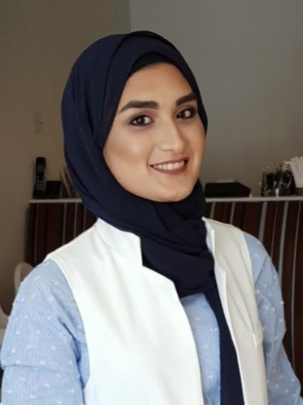

Rabia Asif Qureshi

**[BSc in Business Management]**

Contact No. (+973) 34004558

Email: [rabia_2611@yahoo.com](mailto:rabia_2611@yahoo.com)

|  |
| --- |
| Professional Exposure |
| Wellflow Gulf Trading WLL  Administrative Assistant & Secretary  *September 2020 - current* |
| * Provide full admin support to the team and department * Perform data-entry, documentation, printing and filling duties * Maintain a proper and user friendly filling and document control system for recording and tracking of all documents * Create and maintain useful databases for the company * Assist in any ad-hoc duties, projects and activities as and when required * Support sales team by maintaining database, inventories and preparing quotations * Handling and maintaining of incoming and outgoing couriers |
| Wesal Jewelleries Co W.L.L  Administrative Manager cum HR  *July 2018 – June 2020* |
| * Recruiting, hiring, and training new employees and updating internal databases with new hire information. * Handling of visa application, SIO, LMRA, Tamkeen and undertaking the expenses * Handling of employee’s payroll and personal database * Handling of travel documents and hotel bookings * Respond to incoming communications, such as phone calls and emails * Preparing necessary documents for the company * Maintain and order necessary office equipment and supplies, as needed |

|  |
| --- |
| Creative E development and Support Admin  Executive & Secretary  *Nov 2016 – June 2018* |
| * Maintain all project documents and associated records in the company’s database * Monitor onsite project teams to comply with project control processes and procedures * Control and distribution of all incoming and outgoing project documents and workflows in accordance with the business and project procedures * Responds to inquiries by clients and visitors in a courteous manner * Making follow up calls to ensure proper organization of sales activities * Responding the phone while maintain a polite, consistent phone manner using proper telephone etiquette * Organize and schedule appointments and assists in preparation of regularly scheduled reports * Updates and maintains office policies and procedures |
| United Bank Limited  Customer Care Representative  *June 2014 - August 2014* |
| * Assisting customers with any information related to banking * Respond to customer inquiries and resolve * Maintain and manage existing accounts * Maintain customer database and update periodically * Refer complex issues to the management * Ensure best practices in rendering services to customers |

|  |
| --- |
| Educational Qualification |
| * Bachelor Degree (2010 - 2015)   (B.Sc. in Business Management)  University of Bahrain   * Higher Secondary Education (2009-2010)   (Intermediate of commerce [I.COM](http://i.com/))  Pakistan School, Bahrain   * Secondary Education (2007 - 2008)   (Science Biology)  Pakistan School, Bahrain |

|  |
| --- |
| Activities and Certification |
| * UOB LIFE (April 2012) * IT Symposium 5 “MY APPS MY LIFE” at University of Bahrain (November 2012) * InJAz at University of Bahrain (2011-2012) * Be Entrepreneurial Program * Business Ethics Program * Company Program (Competition) * Business Symposium 6 “INDUSTRY- THE ROLE AND CONTRIBUTION” at University of Bahrain (November 2012) |

|  |
| --- |
| **Personal Information** |
| CPR no: 911112430  Gender: Female  Nationality: Pakistani  Date of birth: 26th November 1991  Marital status: Single  Driving license: Valid |

|  |
| --- |
| Skills |
| * Skilled with office programs like excel, word and power point * Strong Communication * Problem-solving and written expression * Technical Oversight * Management |

|  |
| --- |
| Language known |
| * English (Spoken &Written) Level- Fluent * Urdu (Spoken &Written) Level- Fluent * Arabic (Understanding) |