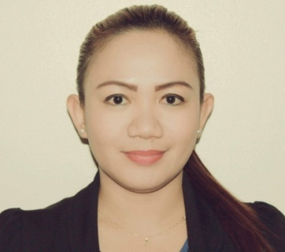
MYRA CHANET M. CARINOTE
Flat 2, bldg. 212, Road 307 Manama 807
Contact No. + 973 3950 4921

OBJECTIVE:
To secure an exciting career in a progressive institution where I can effectively execute my potentials to give valuable contribution for organizational success; harness more knowledge and abilities while employed so as to become a competitive asset of the company.

WORK EXPERIENCES

- Meshal Hotel
Al Hoora, Manama Bahrain
Receptionist

December, 2018 up to present
DUTIES AND RESPONSIBILITIES

- Responsible for operating cash register, processing money, credit and debit card payments.
- Perform responsibilities of calculating daily shift payments received and reconcile with total sales.
- Handle the tasks of greeting guests and providing information on hotel service.
- Perform tasks of accepting reservations.
- Guest handling and problem solving.

- The MunchBox
Galali ,Bahrain
Cashier/Waitress
May 10 – Oct. 20, 2018
- Frsan Palace Hotel
Hoora Exhibition road, Bahrain
Waitress/Bartender
December 7, 2016 – May 10, 2018

DUTIES AND RESPONSIBILITIES
- Take orders and serve food and beverages to patrons at tables in dinning establishment.
- Check with customers to ensure that they are enjoying their meals.
- Take action to correct any problems.
- Communicate with customers to resolve complaints or ensure satisfaction.

- SILVER OAKS SUITES AND HOTEL
Mabini St., Ermita, Manila

Receptionist

April 1, 2016 – December 1, 2016

DUTIES AND RESPONSIBILITIES
- Prepare for the guest arrival.
- Greet the guest when they arrival.
- Check the guest into the hotel.
- Assign suitable rooms and check the guest method of payment.
- They keep a record of the status of each room in the hotel.

- KCC MALL
General Santos City
Sale Lady
July 5, 2008 – July 5, 2011

- YSABEL’S
Riverside Marikina City
CASHIER
January 18, 2006 – January 18, 2008

EDUCATIONAL BACKGROUND

Brokrnshire College
Davao City, Phillipines
BS Nursing (3rd year)

GOLDEN STATE COLLEGE
General Santos City
HRM Undergraduate

TRAINING ATTENDED

INTERCRUISES HOTEL AND RESTAURANT MANAGEMENT CONSULTANCY
4th floor Astoria Building, A. Mabini St., Ermita Manila
March 28 – April 01, 2016
Integrated Skills Preparations and Familiarizations for Food and Beverages / Housekeeping / Bartending and Front Office Service Operations

ON THE JOB TRAINING
Housekeeping February 10-25, 2016
Food and Beverage February 26 – March 26, 2016

PERSONAL INFORMATION
Birth Date : July 26, 1986
Birth Place : Trento, Agusan Del Sur
Height : 5’3 ft
Weight : 53 kg
Age : 33

CHARACTER REFERENCE:
Available upon request.

I hereby certify that the above information are true and correct to the best of my knowledge and belief.

MYRA CHANET M. CARIÑOTE
Applicant

