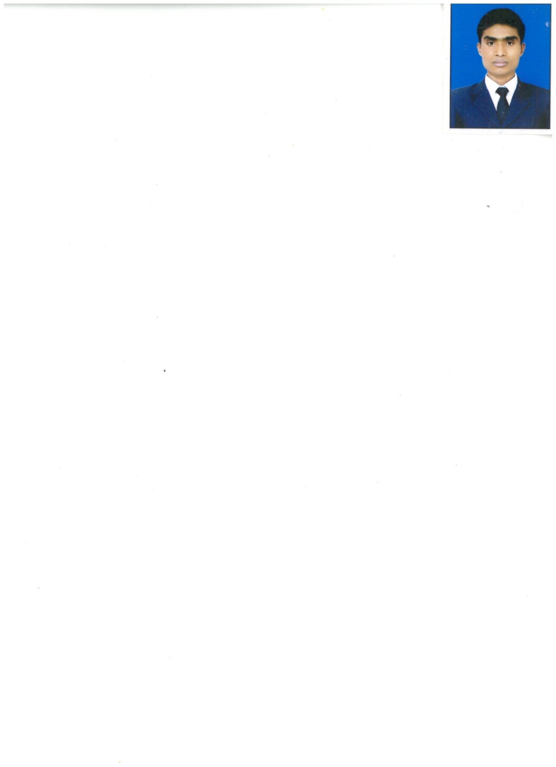

**PERSONAL DETAILS**

**Name---** Pradipta sundar pradhan

Date of birth**–**11/06/1994

**Address:-**Vill:Padmatamli,P.O.:Dumardari P.S.:-Bhupatinagar Dist- purba madinipur, Pin-721425Kolkata West Bengal.

Hand Held: **+97335668011**

Home Ph: **+91 8509561633**

**Skype id:** [**pradiptapradhan96@gmail.com**](mailto:pradiptapradhan96@gmail.com)

**Time to call:** 9am To 9pm (ISD)

**Email:** [pradiptapradhan96@gmail.com](mailto:pradiptapradhan96@gmail.com)

**Area of Interest:**Food and Beverage Service

**Passport No**: **P 0650455**

**Date of Issue: 26/7/2016**

**Date of Expiry: 25/7/2026**

**Place of issue:** KOLKATA

**Career Objective**

To be a part of an organization that offers me a stable and positive atmosphere and inspires me to enhance and therefore to innovate the work culture for the betterment of all parties concerned.

**Educational History**

* Successfully done Diploma IN Hotel Management Course From IIHM. KOLKATA in the year of 2015 to 2016

* Passed Higher Secondary Examination from West Bengal Board in 2011 .
* Passed High School Examination from West Bengal Board in 2009 with all compulsory subjects from West Bengal.

**Professional Experience**

**Pasta Express (A N G Group) Manama Bahrain**

Guest Service Associate (Oct 2017 to Till Date)

**DATE-To-DATE JOB:-**

1. Enters the outlet and cheek the ***Mise en place ,***and Cheek day special menu.
2. Welcoming the guest
3. Escort the guest in the restaurant
4. Siting the guest in a proper way, Place the napkin
5. Showing the menu, Ask for the water
6. Take the order, Informed the guest about the dishes which he ordered
7. Repeat the order
8. Punch the order and place the order
9. Get the food to the guest
10. Take the feedback from the guest

**ITC FORTUNE PARK HOTEL GOA, INDIA**

(Feb2016-Sep2017)

Guest Service Associate (BAR)

**INTERNSHIP**

**ITC FORTUNE SELECT PUNE. INDIA**

(JUNE2015- NOV2015)

* To maintain my log book with daily learning.
* To listen my superior, what he /she is teaching& follow what he/she ordered.
* As a trainee, I have to learn about the basic thing of each & every departments of the hotel.As I was in service department I worked in Restaurant Bar coffee shop, Banquet&IRD.
* Learn how to do guest service and little knowledge of micros.
* I also worked as a pickup man as per the ordered.

**Computer Skills**

 Basic Knowledge of Computer MS Excel, MS Office, MS Word, MS PowerPoint & Knowledge of OPERA.

**Key Skills**

1. Maintaining the cleanliness & Hygiene standards of the area lick restaurant, IRD Cutlery Glass Etc. and back of the Restaurant areas as per HACCP, Diverse Safe key Audit.
2. Maintaining of the entire hotel premises as per LQA & Coyle Audit International standards and reporting the job orders to the engineering.
3. Maintaining the Highest Level of Guest Satisfaction by creating experience for each guest celebrating special occasion, children, single lady traveler, senior citizens, honeymooners etc.
4. Ensuring safety and security of the guest, colleagues and hotel property.
5. I will have an experience on **POS system ezee BURPI. IDS. SOWMEN.**

**Personal Details**

Name- Pradipta Sundar Pradhan.

Father name- Mr. Pratap Prdahan.

Date of birth- 11/06/1994.

Nationality- Indian.

Marital status- unmarried

Height- 5’8

Language known – ENGLISH, HINDI, BENGALI

Hobbies- Playing cricket & watching move

Strength- Positive attitude, smart working

**Reference**

**1. Reference:**

Name -  Mr. Lokesh Mehera.

Post- Ff&B manager

Organization- ITC HOTELS .

Phone- +919008212543

E mail- Lokeshmehera.itchotelsgoa@gmail.com

I hope you will give me an opportunity to serve your organization and I assure you of my best services to the satisfaction of everyone concerned.

Place: KOLKATA (INDIA) (Pradipta Pradhan)

Date: 26th june 2020