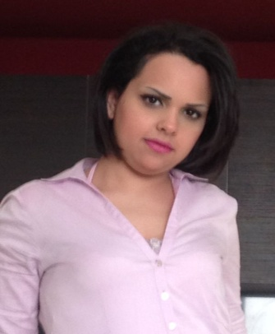

**Ikhlass Raji**

**Personal Information ▼**

**Birth date: 31st of Aug 1988**

**Gender: Female**

**Marital Status: Single**

**Nationality: Moroccan**

**Resident of: Bahrain**

**Mobile: +973 33509004**

**Place of Birth: Morocco**

**E-mail:** [ikhlass.3108@hotmail.fr](mailto:ikhlass.3108@hotmail.fr)

……………………………………………………………………………………………

**Fraser Suites Seef “Luxury serviced apartments"**  February 2015 till September 2020

**(Frasers Hospitality)**

Manama – ***Bahrain***

**Sales Manager**

90 luxurious & spacious suites apartments

**Ramee Grand Hotel & Spa "Luxury 5 stars"**  July 2013 till January 2015

**(Ramee Group of Hotels & Resorts)**

Manama – ***Bahrain***

**Sales Executive “Pre-Opening “**

166 luxurious & spacious rooms & suites

**Al-Murooj Hotel – Juffair** November 2012 till June 2013

Manama, Kingdom of ***Bahrain***

**Sales Executive “Pre-Opening “**

**Gulf Air** December 2008 till December 2011

Manama, Kingdom of ***Bahrain***

**Cabin Crew**

**Ezzahera Primary School**  2007 till 2008

***Morocco***

**Teacher**

**Education ▼:**

#### [L.E.S.M.A Spanish School](http://www.linkedin.com/edu/alumni?name=L%2EE%2ES%2EM%2EA+Spanish+School+-+Morocco&trk=prof-edu-school-name)

##### Diploma

##### "Airline Flight Attendant"

2007 – 2008

Rabat, Morocco

#### Université Internationale du Maroc

##### [English Language and Literature](http://www.linkedin.com/search?search=&keywords=English+Language+and+Literature&sortCriteria=R&keepFacets=true&trk=prof-edu-field_of_study)

2006 – 2007

#### [American Language Center - Morocco](http://www.linkedin.com/edu/alumni?name=American+Language+Center+-+Morocco&trk=prof-edu-school-name)

##### Diploma

##### "English Language"

2001 – 2006

**Languages ▼:**

Arabic : Mother tongue

French : Mother tongue

English : Good command

**Career objective ▼:**

Seeking a suitable post that benefits my potentials and allows me to share & gain experience in order to elevate myself upwards throughout my career.

**References ▼:**

**Upon request**