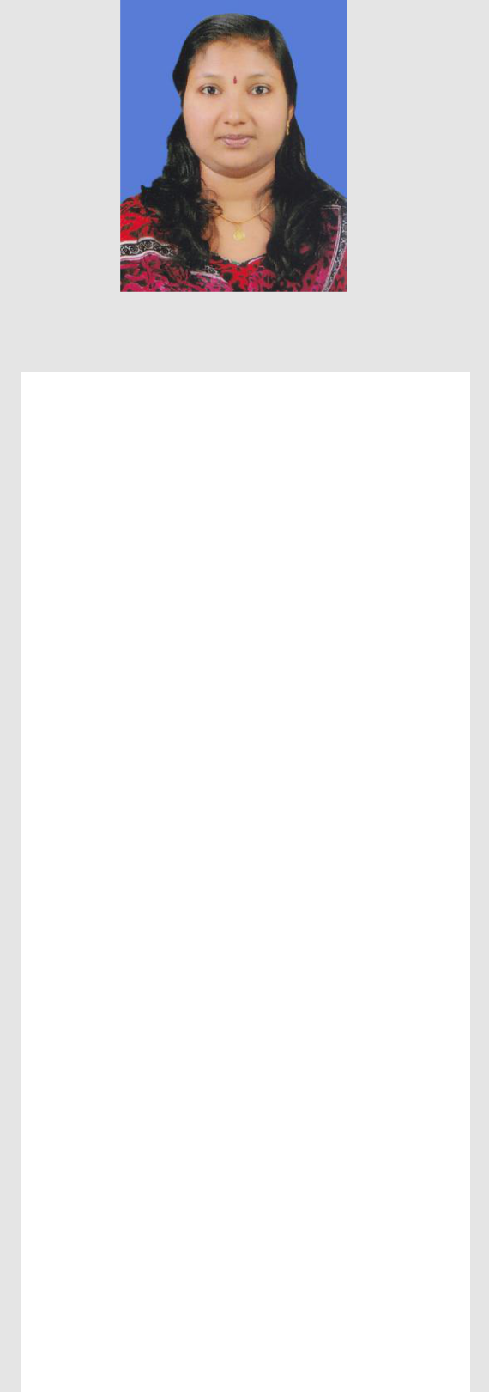

**RAKHI** **R**



**Email:**



[**ramachandran.rakhi@gmail.com**](mailto:ramachandran.rakhi@gmail.com)



**Mobile: +973 34086949**



**ADDRESS**



**VILLA 2599**



**ROAD 1355, BLOCK 913, BUKUWARA, RIFFA, BAHRAIN**



**PERSONAL DATA**

|  |  |
| --- | --- |
| **Date of Birth** | **: 29/01/1987** |
| **Sex** | **: Female** |
| **Nationality** | **: Indian** |
|  |  |



**Marital Status: Married**



**Father’s Name: Ramachandran Nair**



**Religion** **: Hindu**



**LINGUISTIC SKILLS**



**English**



**Hindi**



**Malayalam**



***RESUME***



**PROFESSIONAL SUMMARY:**



* **Software Project Lead with 11+ years experience in Testing domain.**



**EDUCATIONAL QUALIFICATIONS:**



|  |  |  |
| --- | --- | --- |
| **YEAR** | **COURSE** |  |
|  | **MASTER OF SCIENCE: SOFTWARE** |  |
|  | **ENGINEERING** |  |
| **2007 - 2011** | BIRLA INSTITUTE OF TECHNOLOGY & |  |
|  | SCIENCE, |  |
|  | PILANI, **INDIA** |  |
|  |  |  |
|  | **BACHELOR OF SCIENCE: PHYSICS** |  |
| **2004 - 2007** | UNIVERSITY OF KERALA, |  |
|  |  |
|  | THIRUVANANTHAPURAM, **INDIA** |  |
|  |  |  |
| **2002 - 2004** | **PLUS TWO** |  |
| SNSMHSS HIGHER SECONDARY SCHOOL, |  |
|  |  |
|  | ELAMPALLOOR,KOLLAM,INDIA |  |
| **2002** | **SSLC** |  |
| MGD HIGH SCHOOL FOR GIRLS, |  |
|  |  |
|  | KUNDARA,KOLLAM,INDIA |  |



**SKILLS**

* Manual Testing / Regression Testing
* Embedded Firmware Testing / Product Testing
* Strong Domain Knowledge in Imaging and Printing related technologies
* Defining Test Strategy and Test Plan for projects
* Hands on experience in translating business/customer requirements to test requirements and coming up with an effective test design and strategy
* Compiling Test Metrics for management
* Test Management of projects throughout project life cycle
* Planning and estimating
* Defect Tracking
* Automation testing in Common Test Framework

**TOOLS**

* HP Quality Center
* JIRA,TestLink,Redmine
* Virtual Machine Provisioning System (VMPS)
* GIT,SVN
* CTF (Common Test Framework)
* HP Web Jet Admin , HP Digital Sending Software
* Continuous Integration (Jenkins)
* REST API Client
* Python, C#
* Robot Framework
* Selenium

**ACCOMPLISHMENTS**

* Received ‘Feather in My Cap’ award several times in recognition to my work and contributions to the projects
* Received ‘PES Excellence Award’ for the contribution towards best project delivery
* Contributed as Tech Spoc for the Project Readiness Program for the new training batch
* Selected as Technical Panel for the Internship Program
* Selected as ERT Reviewer /SME for the external audit of work product and deliverables
* Certified with PLCP (Project Lead Certification Program)
* Participated in ‘Winning Managers Program’
* Selected as Tech Panel for Campus Recruitment Process
* Received award for significant contribution towards CMMI Dev V 1.3 class A Level 5 Assessment

**WORK EXPERIENCE**

* Worked as Project Leader with **QuEST Global Engineering Services Pvt. Ltd** from November 2016 to January 2019.
* Worked as Test Lead with **Wipro Technologies** from July 2007 to July 2016

**WORK HISTORY**

* **PROJECT LEADER**

Quest GLOBAL ENGINEERING SERVICES PVT LTD, TRIVANDRUM, INDIA**:**



**Nov 2016 - Jan 2019**

* Leading Integration testing team
* Test Estimation, Test Plan preparation and Test Case Reviews
* Integration Testing and Bug tracking
* Release planning and coordinating weekly status calls with customer
* Test execution environment setup for API automation using Jenkins build server
* Handling Integration and API automation team and monitoring the project activities on a daily basis
* Test Plan/test design preparation and test reviews.
* Integration and System Testing
* Co-ordination with Development team for resolution of any outstanding issues
* Project Maturity Audit activities
* Integrated Project Management Tool activities for monthly effort tracking
* **TEST LEAD**

**WIPRO TECHNOLOGIES, KOCHI ,INDIA : Jun 2014 – Jul 2016**

* **SOFTWARE TEST ENGINEER**

**WIPRO TECHNOLOGIES, KOCHI ,INDIA : Jun 2012 - May 2014**

* **SOFTWARE TESTER**

**WIPRO TECHNOLOGIES, BANGALORE ,INDIA : Nov 2007 - May 2012**

* Test Requirements Analysis for new enhancements, estimate, plan and review of deliverables
* Co-ordinate preparation of Test plan/design/document, test suite and user documentation.
* Set-up of Automation test lab, execution of automated and manual tests
* Ensure configuration management activities related to testing
* Running automated tests and manual tests, analyze the results
* Plan and implement defect preventions activities at project level
* Integration and System Testing
* Identify and implement reusable test software
* Handling Regression team and monitoring the project activities on a daily basis
* Planning of a release based on the permutation and combination of resources, time line and requirement
* Preparing and reviewing traceability matrix and requirements coverage in test plans/test cases
* Solving technical issues in lab and ensuring that all relevant setups are available or alternatives planned while committing to requirements
* Conducting peer reviews and tracking team's failed/blocked test cases to closure
* Preparing status reports and audit documents for ERT reviews/external audits
* Timely response to customer requests
* Preparing Billability and monthly PDMR reports
* Tracking and maintenance of project records in common database repository
* Training new engineers and conducting knowledge sharing sessions

|  |  |
| --- | --- |
| **PERSONAL DETAILS** |  |
| Date of Birth | 29/01/1987 |
| Nationality | Indian |
| Marital Status | Married |
| Languages Known | English,Hindi,Malayalam |
| Passport No: | T3118725 |
| Date of Issue | 30/01/2019 |
| Date of Expiry | 29/01/2029 |
| Place of Issue | COCHIN |