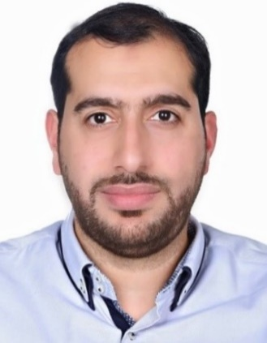

MOHAMED AHMED ABDULGHAFFAR

**Overview**

**Experienced Educational Technology Specialist with a demonstrated Background in Mass project planning, management and execution and Leading Digital Transformation within the educational industry. Key Skills held are Project Management, IT and Digital Transformation Strategies.**

**Date of Birth : 10th July 1984**

**Nationality : Bahraini**

**Languages : Arabic, English**

**Education**

**2013 – 2014**

**Ernst and Young Training Institute**

CIMA Professional Certificate

*Finished three papers*

**2002 – 2006**

**Leeds Beckett University (UK)**

BSc Multimedia Technology (Hons)

**Main Skills**

* Strong Problem Solving and Critical Thinking skills.
* Strong IT and Technical Skills.
* Strong administrative and communication skills.
* Proficient in M365 applications, including Teams, SharePoint, OneDrive.
* Graphics design and Video Production.
* Well-organized and Result-driven.
* Adaptive and Quick learner.
* Keen to learn and expand my knowledge.
  + Strong IT Skills.

Screen%20Shot%202018-01-07%20at%2012.00.23%20PM.png

**Contact**

## (+973) 39754475

## [Mohd.ah.ghaffar@gmail.com](mailto:Mohd.ah.ghaffar@gmail.com)

<https://www.linkedin.com/in/mohamed-ahmed-abdulghaffar-00185a71>

**Experience**

**King Hamad’s Schools of the Future Project**

**Information Technology Specialist Utilization Team**

(Sep 2006 – Current)

**Main Projects worked on:**

* **Cloud File-Sharing:**
* Setting up a cloud file-sharing program for the Directorate using Microsoft Groove (2007), Microsoft SharePoint Workspaces (2010), Microsoft Teams and OneDrive (2019).

**Digital Online Forms:**

Transforming the traditional paper forms into digital online forms using Google and Microsoft forms.

**Current Project:**

Designing a customized dedicated system for the Directorate in order to retrieve and analyze data and statistics from all government schools (204) regarding the Digital Empowerment in Education project implementation.

**Other Tasks and Duties:**

* Meeting with schools' administrations and e-Learning Teams to follow-up with their progress in the digital transformation progress and offer new solutions and consultation.
* In charge of directorate hardware, software and network setup and troubleshooting.

**Other Experiences**

**Gulf Air Headquarters**

Accounts Payable

(2005)

Summer Training

**Extracurricular Achievements**

Represented the King Hamad’s Schools of the Future Project in Exhibitions and Functions organized by the IGA both locally and internationally.

Was part of the MOE team to support and maintain Distant Learning efficiency during the current COVID-19 Pandemic.