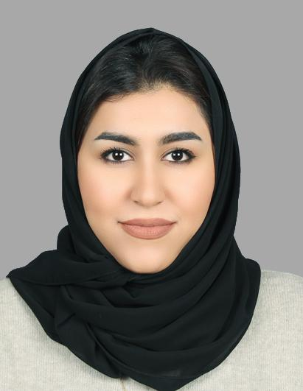  Jinan Ahmed Ali Ehdayah  Profile  ADDRESS:  VILLA 367 ROAD1322 BLOCK813  ISA TOWN-BAHRAIN  DATE OF BIRTH:  09th OF May 1995  NATIONALITY:  Bahraini  CPR No.: 950501808  Contact  PHONE: 36667762  EMAIL:  JENANNAHMED@HOTMAIL.COM  Hobbies  TRAVELING, INTERNET AND SHOPPING |  | EDUCATION  Al Noor secondary school (2013 – 2015) High School Certificate (Commercial)  ARAB OPEN UNIVERSITY (2015 – 2019) Bachelor’s degree, business Studies System, systems track.  WORK EXPERIENCE  Works as Call Center agent (outsourced for many companies, such as: Solidarity and Now Insurance. Respond to incoming calls from the customers to take meet their requirements, answer questions and inquiries in the perspective of the motor, home and life insurance.  (2017) Braxtone group Call Center and customer service Representative.  Now broker insurance customer service representative (outsourcing of braxtone group).  Educated customers on product and service details and information, assisted customers by answering questions, responding to inquiries, and handling telephone requests and Recommended policies to customers, thoroughly explaining details.  Solidarity Bahrain B.S.C. Customer Service Representative (Outsourcing part of braxtone group).  Inbound and outbound calls, issuing and renewing the policies and Calculating premiums and payment methods and processed.  Hilal takaful is a wholly owned of Al Hilal bank, customer service representative (Outsourcing part of braxtone group).  Inbound and outbound calls, issuing the policies and Calculating premiums.  SKILLS  Languages Speak Read Write  Arabic ✓ ✓ ✓  English ✓ ✓ ✓  other skills  Good command over Microsoft office, fully capable of using computer and internet, analyzing data, Team working and interpersonal skills, Communication skills, Good multi-tasking skills.

