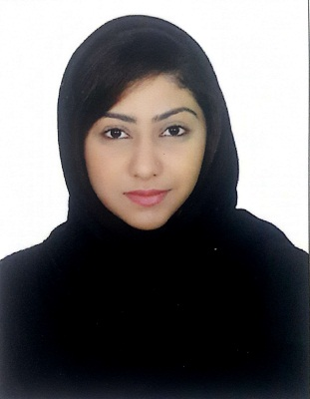
Salwa Nasim Ejaz

E-mail: salwanasim98@gmail.com

Voice: +973 33455652

Summary
Worked as a Sales Executive where handled all inquiries related to nature of problems. An Individual who believes in hard work and commitment, a true team player and an individual who never hesitates to take ownership of the tasks that are assigned.

PROFESSIONAL EXPERIENCE
Al Sham Perfumes 2016 ( 3 Months )
- Analyzed competitive products in terms of reliability and features.
- Reviewed entire inventory lists on a daily basis to keep track of inventory flow.
- Identified resource requirements and assigned responsibilities to different sales staff through proper coordination.
- Helped in resolving critical issues related to sales, and escalated important matters to upper management.
Extra World - 2017

- Worked as Sales Promoter in various supermarket in Bahrain
- Set and achieve personal sales goals while supporting the goals of the team
- Greet customer in a timely, professional and engaging manner
- Provide honest and confident feedback to customers regarding merchandise style and fit
- Building rapport with customer by contacting them to follow up on purchases
- Consistently seek new product knowledge to act as an expert for the customer
- Making outbound phone calls/ taking inbound phone calls/ sending/answering customer emails.

EDUCATION

-2017 Higher Secondary - Pakistan Urdu School B Grade
-Packages MS Office

I.T & LANGUAGE SKILLS
- Proficient in MS Office Applications
- XP/ Vista/ Windows 7/Windows 8
- - Fluent in Arabic, English, Urdu

PERSONAL SKILLS & ACHIEVEMENTS
- -Good time management skills
- Dealing with customers and clients in a professional manner
- Establishing and maintaining positive customer relationships
- Effectively presenting information
- Ability to lead and motivate
- Dedicated, self-driven and result-oriented
- Comfortable to work in rotating shifts and overtime if required
- Ability to deliver the best results even during the most stressed situations at work
- Excellent multitasking and organizational skills
- Valid Bahraini Driving License

Nationality Bahraini Single Date of Birth 22-Nov-1999

