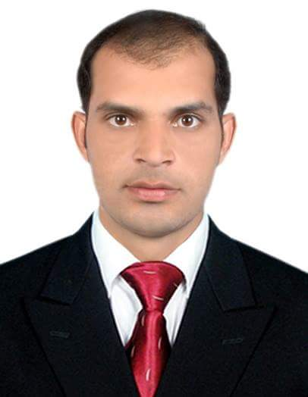

**AZEEM AKHTAR**

# OBJECTIVE

### Seek position that utilizes the best of knowledge and abilities especially in Operations Management and Control to help company’s goal and stability attainment. Also search for career advancement and learn new things and explore challenges to deepen expertise.

* Name Azeem Akhter
* Father Name Muhammad Siddique
* Date of Birth 06 June 1989
* Nationality Pakistani
* Religion Muslim Islam
* Status Married
* CPR 890629560
* Hobbies Watching Talk Shows, Use the Internet playing Badminton and cricket
* Mobile 00973,36783823 (with all apps active)
* Address Manama. Kingdom of Bahrain.
* E-Mail Address [Akhtarazeem988@yahoo.com](mailto:Akhtarazeem988@yahoo.com) [malikismalik786@gmail.com](mailto:malikismalik786@gmail.com)

# EXPERTISE

* MIS & Epicor (Material Information system)
* Microsoft Office Internet & E-Mail.
* MS Office tool (word, excel, power point)
* Installation & uninstalling software.
* Microsoft Windows installing.
* Computer hanging on team viewer.
* To excel within a highly competitive & challenging work environment where leadership Skills are the keys to success.

# EDUCATION

Government primary School, Sialkot Pakistan

**Elementary Diploma 1999**

Government high School, Sialkot Pakistan  **2005**

**High school Diploma**

Government degree College Sialkot  **2007**

# College Diploma

Government degree College Sialkot  **2009**

# College Diploma Bachelor of arts.

# EXPERIENCE

***Key Responsibilities:***

* Material planer and material consumption controller in BFGI (Bahrain fiber glass international) 05years.
* Inventory controller working in BFGI.
* Raw Material foreman in BFGI (Bahrain fiber glass international) 03years.
* Raw material expiry management system controller.
* Handling the material cabin kitting and issuance in MIS system (foreman in BFGI).
* Material incoming and outgoing in MIS system (foreman in BFGI).
* Assistant manager of Labeling in Forward gear Pakistan (03year).

# 

# Personal Assessment

* Good teamwork solves the challenges & Problem-solving attitude.
* Devoted and honesty working behavior.
* Driving motorbike, car & forklift.
* Planning and organizing.
* Decision-making.
* Co-ordination skills.
* Positive attitude.
* Confident.
* Creative and innovative.
* Dependable and responsible.
* Hardworking & Honest

I hereby certify that the above information is true and correct to the best of my knowledge and belief.