|  |
| --- |
| **Kimberly Jane C. Casupanan, RPm**  **Flat 1, Bldg. 42, Road 302, Block 103, Al- Hidd, Kingdom of Bahrain**  **Contact No: 3407 1628 (WhatsApp)**  **Email Address: kimcasupanan11@gmail.com Web:**  **https://www.facebook.com/kHimhiE** |

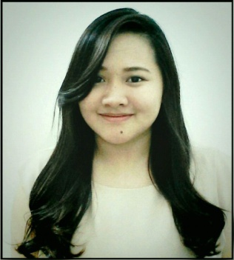

|  |
| --- |
| **Objective** |

To provide the best assistance for the client using my skills and knowledge I acquired from class room settings, previous, and current working experiences**.**

|  |
| --- |
| **Personal Information** |

**Nationality :** Filipino **Weight :** 60kg

**Birthday :** April 11, 1995 **Religion :** Roman Catholic

**Age :** 25 **Blood Type :** B+

**Civil Status :** Single **Sports :** Taekwondo and Volleyball

**Achievement**

**Registered Psychometrician:** July 2015 - Board Licensure Examination for  
 Psychometrician

|  |
| --- |
| **Work Experience/ On the Job Trainings** |

**Manama Manpower**

Al Salmaniya/Manama Kingdom of Bahrain

September 3, 2019 up to Present

Secretary

**Red Oak Interiors W.L.L.**

Adliya, Kingdom of Bahrain

November 11, 2018 to September 1 2019

Secretary

**Al Samawi Businessmen Services**

Al Salmaniya, Kingdom of Bahrain

June 15, 2017 to November 10, 2019Supervisor **Negosyo Center- Bulacan (under DTI)**Hiyas ng Bulacan Convention Center

July 11, 2016 to May 8, 2017

Jr. Business Counselor

**Aven Fashion Manufacturing Inc.**

1072 J.P St., Sta. Barbara, Baliuag, Bulacan

November 9, 2015 to June 10, 2016  
Hr Assistant/Time Keeping/Payroll **Racal Motorsales Corporation**Bocaue, Lolomboy Bulacan

July 2014 to September 2014

Industrial Settings – 150 hours

**Bulacan Polytechnic College**

Bulihan, City of Malolos, Bulacan

September 2014 to November 2014

Educational Setting- 100 hours

**Over the Top Psychiatric and Custodial Care Center**

357 Santissima Trinidad Malolos, Bulacan

December 2014 to January 2015

Clinical Setting – 200 hours

|  |
| --- |
| **Education** |

**Tertiary: 2011- 2015** **Bulacan State University**

Bachelor of Science in Psychology

Guinhawa, City of Malolos, Bulacan

|  |
| --- |
| **Seminar** |

* ***Suicide Risk Factors Assesment***

February 1, 2012

* ***Extracting Your Juices: A seminar Workshop on Creative Counseling***

March 29, 2014

* ***SALIKSIKOLOHIYA 2015: Research Exhibit***

March 10, 2015

|  |
| --- |
| **Skills** |

* Proficient in using Microsoft Office Application such as:

Microsoft Office Word, Microsoft Office, PowerPoint

* Has a background in Psychological Tests such as:

Intelligence test, Personality Test and Interest Test

* Accuracy and Attention to *details.*

**Character References**

Michelle O. Cahulogan

Al Samawi Businessmen Services

Secretary

+973 3722 3215

*I hereby certify that the above information are true and correct to the best of my knowledge.*

____________________________ _________________________________

**Date** **Kimberly Jane C. Casupanan**