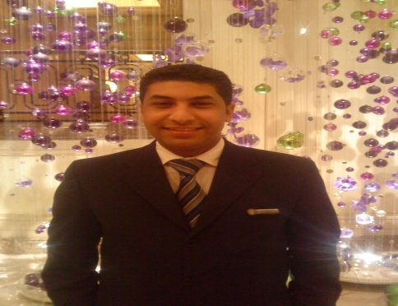
Fahmy awad fahmy
Fahmyawad47@yahoo.com

Phone: 00201004805013

Mobile

00201006166036.
0097335477129

Personal Data

Nationality | Egyptian.
Date of Birth | 25/06/1983.
Gender | mail.
Marital Status | married

Education

Commercial technical academe,

Graduation year | May (2001\2002) .
General grade | good.
University | Technical Commercial Institute

Languages

Arabic | Mother Tongue .
English | Good command of English .
Cours
Training Taken

Four Seasons Hotel at the first residence 2007 to 2015
Four seasons maldives (Guest Services Department) 2015 to 2016
Four Seasons Kuwait(Guest Services Department) 2017 to 2018
Four Seasons Bahrain (Guest Srvices Department) 2018 to 2020
Computer Skills

- Diploma in brofisnail secretary
- (I d c l .v5) form yat edyction com
- Diploma in computer science from cairo university
- Livel 8 form american university in cairo
Objectives

- To get a Highly Experience in my field.
- To gurantee my future with a good position .
- To work at a large Company With an effective Team work .
Additional Comments

- I am very cooperative and flexible person.
- I can work in individual or in a work group.
- I am a dynamic, hard worker and self-motivated.
- Excellent interpersonal & communication skills.
- I will do my best to enhance myself and to achieve the company goals .
Hobbies
- Swimming.
- Reading .
- Traveling.

