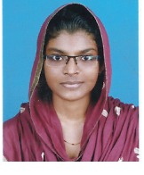**SUBINA K**

Mobile: +973-36347844

Mail:subinak@gmail.com

## CAREER OBJECTIVE

My goal is to become associated with a company where I can utilize my skills and gain further experience while enhancing the company

## ACADEMIC QUALIFICATIONS

* First class in BTech civil under CUSAT from KVM College of Engineering, Cherthala, Alappuzha, Kerala

## COMPUTER SKILLS

* AutoCAD (2004 – 2017)
* MS Office
* Sketch up

## PERSONAL DATA

Age : 24 years

Gender : Female

Marital status : Married

Husband’s name : Fanzeer B

Nationality : Indian

Passport No. : T9598818

Issued at : Cochin

Valid Upto : 14/10/2029

Current Address : Ghuraifa ,Bahrain

**DECLARATION**

I hereby declare that all statements made in this are true, correct and complete to the best of my knowledge and belief.

**(Subina k)**