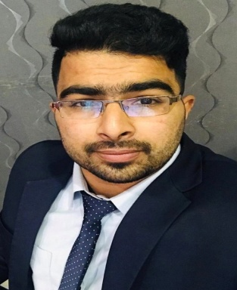
CURRICULUM VITAE

SACHIN CHANDRASHEKAR

sachincshetty1@gmail.com
Mobile No: +973 33716198,

OBJECTIVE

- I am looking for a challenging career within your esteemed organization where I can express my hard working, ambition energetic team work capabilities along with my accumulated experience and a career that can offer the chance for continues development, advancement and enhancement for this profane.

Work Experience:

Organization

Manama Tower Hotel , Hoora, Kingdom of Bahrain
- Post : Receptionist
- Period : March 2018 to July 2019.
- Software : IDS NEXT

Organization

Aspire Tower Juffair Kingdom of Bahrain
- Post : Receptionist
- Period : July 2019 to March 2020
- Software : WINHMS

Qualification:
- S. S. L. C : (State board) VSS Public School, Srinivas Nagar Bangalore -2014.
- P.U .C : (State board) Brindavan College Hanumanth Nagar Bangalore-2016.
- Computer Diploma : Manipal Institute of Computer Education - 2017 .

TECHNICAL SKILLS
- Basic in Computer MS Office, Internet, Paint Shop.
- Microsoft Word, Excel, PowerPoint, Internet Applications.

Assets
- Ability to chase stretched target and perform with a high energy level.
- Ability to handle team motivates them and results from them.
- Self motivate and hardworking.
- Ability to quickly learn and master.
- Valid Bahrain Driving License

Hobbies

- Playing cricket. Football. Swimming & music.

Personal Details
Name : Sachin Chandrashekar
Father name : Chandrashekar Shetty
Date of Birth : 18/01/1997
Sex : Male
Marital Status : Single
Nationality : India
Passport no : R 2118781
Visa status : Bahrain Residential Visa
Language known : English, Hindi, Kannada and Arabic
Permanent Address : Kenjoor Village, Udupi Distric,Karnataka

DECLARATION

I hereby declare that all the above statements are true, correct to the best of my knowledge and belief.

Place: Bahrain Signature

Sachin Chandrashekar

