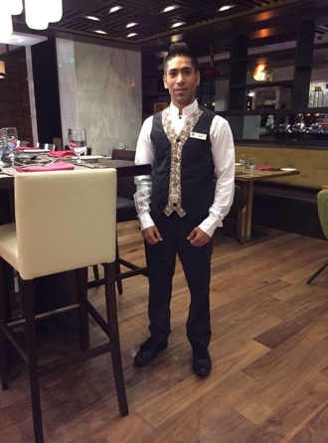

**Ganesh Dumre**

**RAMADA ENCORE DOHA**

**P.O. Box: - 200922**

**Doha, Qatar**

**Mobile: - +974-77164816**

**Email Id: - gdumre@gmail.com**

**OBJECTIVE:**

**To be employed in a service industry by imparting my skills and knowledge that contributes as an asset to the company**.

**Position Applying*:* Waiter Captain**

**WORK EXPERIENCE**

**RAMADA ENCORE DOHA**

**Waiter Captain**

**Aug 2018 till Now**

**DOUBLE TREE BY HILTON RIYADH, K.S.A**

**Waiter**

Apr 2015 up to 2018 July

**QASR Al SHARQ, WALDORF=ASTORIA HOTELS AND RESORTS.**

**JEDDAH, K.S.A.**

May 2009 up to 2013 May

K.S.A Jeddah

**Butler**

**Duties & Responsibilities:**

* Greet and escort guests to their rooms.
* Provide quality and personalized services to guests.
* Assist and coordinate the arrivals and departures of guests.
* Handle guests' luggage and other baggage.
* Ensure cleanliness of suites for guests.
* Manage guests' special requests delivery.
* Provide exceptional and memorable services to guests throughout their stay.
* Manage guests' garment pressing, shoeshine and other services.
* Follow-up and ensure that guests' requests are met in a timely manner.

**GRAND HOTEL**

Jan 2007 to Feb 2008

**Waiter**

**Duties & Responsibilities:**

• Maintenance and up keep of all service equipment / materials.

• Responsible for getting stock for stores and maintaining hygiene standards in storage.

• Ensure minimum wastage, spoilage of food and drink.

• Preparing tables for a meal

• Taking customers' orders

• Serving drinks and food

• Cleaning up before, after and during servings in a restaurant

• Preparations before, and after the service (mis-en-place and mis-en-scene)

• Inform supervisor immediately on any operational and guest related matters.

• Maintain cordial and professional relations with all hotel employees.

• Show interest in and understanding for other departments processes

• Develop and maintain good working relationships with all kitchen and stewarding staff.

• Pleasant interaction with guest and always ready to serve.

• Adhere to all the Leisure Brand Standards - General Standards of Behavior.

• Maintaining hygiene and cleanliness standards in the outlet / service areas.

**EDUCATIONAL BACKGROUND**

* 2006 to 2007 Hotel and Catering Management

Nepal Tourism and Hotel Management Collage

* 2003 to 2005 Higher Secondary (+2)

Pasang lhama Sherpa Higher Secondary Collage Kathmandu Nepal

**TRAININGS and SEMINARS**

* Fulbari Resort Pokhara Nepal 2007 ( for 6 months)

Waiter (trainee) worked in all major department.

**PERSONAL DATA**

Nickname : Ganesh

Date of birth : September 11, 1986

Place of birth : Nepal

Height : 5’4

Weight : 120 lbs.

Religion : Hindu

Language : English, Hindi,Arabic