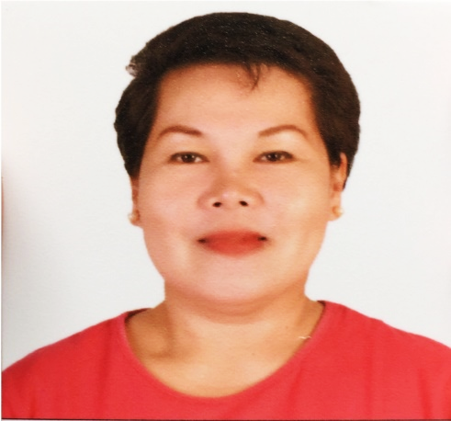
N O R A T A D E N A B A C O L
Blk 6 Lot 17 Dexterville Homes Subdivision,
Malagasang I-C, Imus City, Cavite, Philippines
09495022315
norabacol@yahoo.com

PERSONAL INFORMATION
Status: Married Nationality: Filipino Language: Tagalog, English,
Date of Birth: March 5, 1969 Religion: Catholic Bisaya, Arabic

education
1986 – 1988 | Butuan Doctors College
- Junior Secretarial Major in Medical Secretarial

working EXPERIENCE
April 2009 – May 2010 Medical Secretary
Ophthalmology Clinic | Butuan Doctor’s Hospital
- Responsible in the clinic and medical supplies needed by the patient for any minor procedure done in the clinic daily
- Communicates patients personally or through phone
- Issues receipts and receives professional fees
- Keeps patients’ records, financial records, etc.
- Makes the monthly report inventory

January 2005 – December 2008 Medical Secretary – Head of Department
Ob-Gyne Clinic / IVF Clinic | Bahrain Specialist Hospital
- Supports the chief of the department in all clerical work
- Charges all the daily consumables and laboratory entry as well as radiology in all physical tests using HMIS program
- Types medical reports if needed
- Keeps patients’ records, financial records, etc.
- Assists the chief of departments, resident doctors and nurses
- Requests supplies (medical and non-medical) for the department
- Assists BSH marketing if it is needed
- Prepares the monthly report

January 2003 – 2005 Unit Manager Secretary / Ward Clerk
Bahrain Specialist Hospital | Kingdom of Bahrain
- Performs all duties within the scope of the hospital policies, procedures and protocols
- Maintains a secure filling and office management system for the assign clinical manager and nursing staff
- Screens and directs incoming calls from the clinical manger
- Communicates clearly and effectively with other departments in tracking information
- Supports the clinical manager, charge nurse and staff nurse
- Maintains confidentiality of all reports, documents, information seen or heard off within the unit
- Charges consumables used by the patients using Hospital Managements Information System (HMIS)
- Knows how to operate a computer especially Microsoft Word and Excel
- Assists in maintaining personnel documentation, staffing, profiles monthly report and duty schedules
- Performs duties related to admission, transfer and discharges, to assist nursing staff with computer entries, telephone calls, and documentation
- Assists doctors during immunization day
- Utilizes the HMIS program

May 1997 – February 2000 Medical Records Data Entry Clerk
King Abdul-Aziz University Hospital | Jeddah, Saudi Arabia
- Responsible for Data Entry Section using OASIS/ Intel Health Program
- Receives files and investigation results daily
- Receives calls for Out- Patients Department (OPD) appointment from different units’ patient discharges daily
- Maintains confidentiality for patients’ records

September 1993 – March 1996 Medical Secretary
Pediatric Department | Prince Abdullah bin Abdul-Aziz Hospital, Saudi Arabia
- Total professional secretarial management of the department office
- Takes medical dictations and secretarial support to the head of departments and another clinic consultant
- Responsible for department supplies, equipment and inventory
- Management of files including patients’ file, incoming and outgoing memos, doctor files, confidential files, and referral files
- Writes correspondence such as memos and appointment
- Makes duty roster schedules for clinical and on-call doctors
- Acts as a receptionist / coordinator during hospital lecture
- Prepares medical reports and documentation for the transfer of patients to other hospital
- Types discharge summaries, death report and monthly statistics reports in the department

May 1988 – September 1992 Medical Secretary
Pediatric Department | Butuan Doctors Hospital
- Receives calls for the appointment of patients
- Assists doctors during immunization day
- Contacts patients both in person and through the telephone
- Keeps financial records, patients file etc.
- Types medical reports requested by the patient
- Responsible for the office supplies that are needed in the clinic or in the office.
- Issues receipts and receives professional fees

REFERENCES
- Dr. Eduardo C. Tan
Consultant Ophthalmologist
Butuan Doctor’s Hospital
Butuan City, Philippines
dockins12@yahoo.com

- Dr. Salem Jibrel
Consultant & Head Obstetrics and Gynecology Services / IVF Director
Bahrain Specialist Hospital
P.O. box 10588
salam@bsh.com.ph

- Dr. Farah Sulaiman Al- Nuaimy
Consultant Ob- Gyne
Bahrain Specialist Hospital
P.O. box 10588
farahob@bsh.com.ph

- Ms. Thelma Cacapit
Director of Nursing
Bahrain Specialist Hospital

- Mr. Rasheed Al- Johani
Director of Medical Records
Jeddah, Kingdom of Saudi Arabia

- Mr. Alfred Newton
Consultant Chief of Pediatric Department
Prince Abdullah Hospital
Bisha, Kingdom of Saudi Arabia

- Virgie Gumpal
President of Homeowners of Association
Dexterville Homes Subdivision
Imus City, Cavite, Philippines

- Teresa Palaje
Barangay Health Worker
Malagasang 1st Health Center
09194503854

