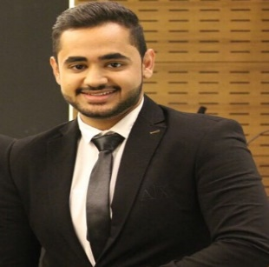**Emad Hasan Ahmed Seroor  
Mobile no. 36833433**

**Email address:** [**emad.eh@yahoo.com**](mailto:emad.eh@yahoo.com)

**Career Objective:** To be a part of company that indulges professional growth which provides challenging and rewarding career while allowing me to utilize my knowledge and skills.

**Educational Attainment:** Al Rawabi Private School (2013-2016)

**Strengths:**

* Proven initiative and ability to work with minimal supervision
* Good team player and multitasking capabilities
* Fast learner and dedicated in delivering team success
* Communication Skills (English and Arabic)

**Additional Skills**:  
Proficient in the following:

* MS Office Application (Word, Excel and Power Point)
* MMA Fighter
* Football
* Jiu Jitsu

**Work Experience: VIVA/STC Telecommunication Company (February 01, 2017- November 30, 2019)**

**Customer Service Representative**

* Answers incoming customer calls regarding billing issues, product problems, service questions and general client concerns.
* Responsible for maintaining a high level of professionalism with clients and working to establish a positive rapport with every caller
* Update customer information in the customer service database during and after each call
* Work with the management team to stay updated on product knowledge and be informed of any changes in company policies
* Impact the company’s bottom line by problem solving and turning frustrated clients into repeat customers
* I have worked is all mentioned departments: Customer service agent , Complains team agent , Roaming team agent , Active team leader , Multimedia team , Inbound sales team

**Achievement:** Qualified to ITIL Foundation Level 6.0