**Curriculum vitae**

**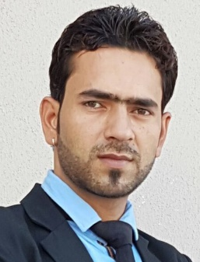 *TAHIR MOHI-UD-DIN SHAH***

Mob. No: +973 33510003,

CPR No: 910325790

Passport No: J8999997

Driving license no; 910325790

Email: [shahtahir831@gmail.com](mailto:shahtahir831@gmail.com)

***CAREER OBJECTIVE:***

Seeking to work challenging working environment where I should have an opportunity to utilize my Education, knowledge & Skill and grow as not only a professional but a good human being as well.

***WORKING EXPERIENCE:-***

* Two-year experience from Vibrant Security services as security supervisor Cum Control Room In charge (Bahrain.)
* One-year experience as front office executive from the Hotel Grand Mumtaz Pahalgam Srinagar Kashmir India.
* One-year experience as front office executive from the Hotel Private Affairs GK 1 New Delhi India
* One-month training from the Ahmad Hospital IN First Aid and BLS for the emergence cases.
* 5 Years working in kingdom projects Manama as project coordinator cum sight in charge.
* Six Months working In ALBA and Gulf Air As Operational In charge responsible for Housekeeping , Safety, Store , Ect
* Presently working in Al Saadoon as Operational Officer/ Operational in charge Responsible for Housekeeping, Safety, Store, Transportation, site inspections Etc.

**Job description**

Maintaining and monitoring project plans, project schedules, and Store ledgers work hours,

Organizing, attending and participating in stakeholder meetings.

Documenting and following up on important actions and decisions from meetings.

Ensuring project deadlines are met.

Determining project changes.

Providing administrative support as needed.

Undertaking project tasks as required.

Ensuring projects adhere to frameworks and all documentation is maintained appropriately for each project.

Assess project risks and issues and provide solutions where applicable.

Ensure stakeholder views are managed towards the best solution.

Chair and facilitate meetings where appropriate and distribute minutes to all project team members.

Create a project management calendar for fulfilling each goal and objective.

Safety Classes,

***ACADEMIC QUALIFICATION:***

* 10th Passed from Jammu and Kashmir state board of school education
* 12th Passed from Jammu and Kashmir state board of school education
* Graduation from Kashmir university

***TECHNICAL QUALIFICATION:***

* One year Diploma in Aviation, Hospitality, & Tourism from VIINZSCollege Srinagar (J&K)

***Interpersonal Skills:***

* Motivational
* Keen learner
* Enthusiastic
* Very Professional
* Team worker
* Ability to cope up any challenge
* Great presentation skills
* Great communication skills
* Time specificity and ability to work under pressure.

***PERSONAL PROFILE***

Date of Birth:            04/03/1991

Marital Status: Single

Religion:                     Muslim

Sex:                              Male

Nationality:               India, Kashmir

Language: English, Hindi, Arabic Urdu & Kashmiri

Height: 183 cm.

***DECLARATION:***

I hereby declare that all the above information given is true to the best of my knowledge.

Date:                                                                (Tahir Mohi-ud-din Shah)