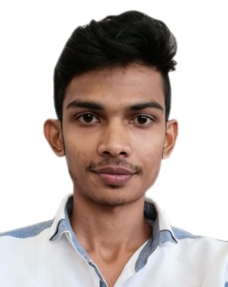**C.V.**

**Shah Neowaz Abddus Sattar**

**House 72D, Road 02, Block 606, Sitra, Bahrain**

**Mobile: +973 39215663**

**E-mail: srnsunny143@gmail.com**

**Personal Details**

**Nationality: Bangladeshi**

**Date of Birth: 01-January-1991**

**Place of Birth: Comilla**

**Status: Single**

**CPR Number: 910193436**

**Objective**

To obtain a position where I can develop my skills and experience to reach a high management position.

**Educational Qualification**

**Higher Secondary Certificate**

**Al Haz Nur Mia College & University**

**Secondary School Certificate**

**Tarashail High School**

**Additional Skills**

* **Languages:**

**Language Speaking Reading Writing**

English V.Good V.Good V.Good

Arabic Little bit Little bit Little bit

Hendi V.Good N/A N/A

* **Interpersonal:**
  + - Good dealing with people.
    - Fast leaner with an enthusiasm to improve self.
    - Like to work with a creative teamwork.
    - Reliable and hard working.
    - Ability to work under pressure and deadlines.
* **Computer:**
  + - Dealing with Microsoft operating system.
    - Excellent skills in MS Office.
    - MS Excel
  + **Experience : Waiter 6 month**
  + **Computer Operator – 01-05-2018 to Rannig, Alghadeer Document**