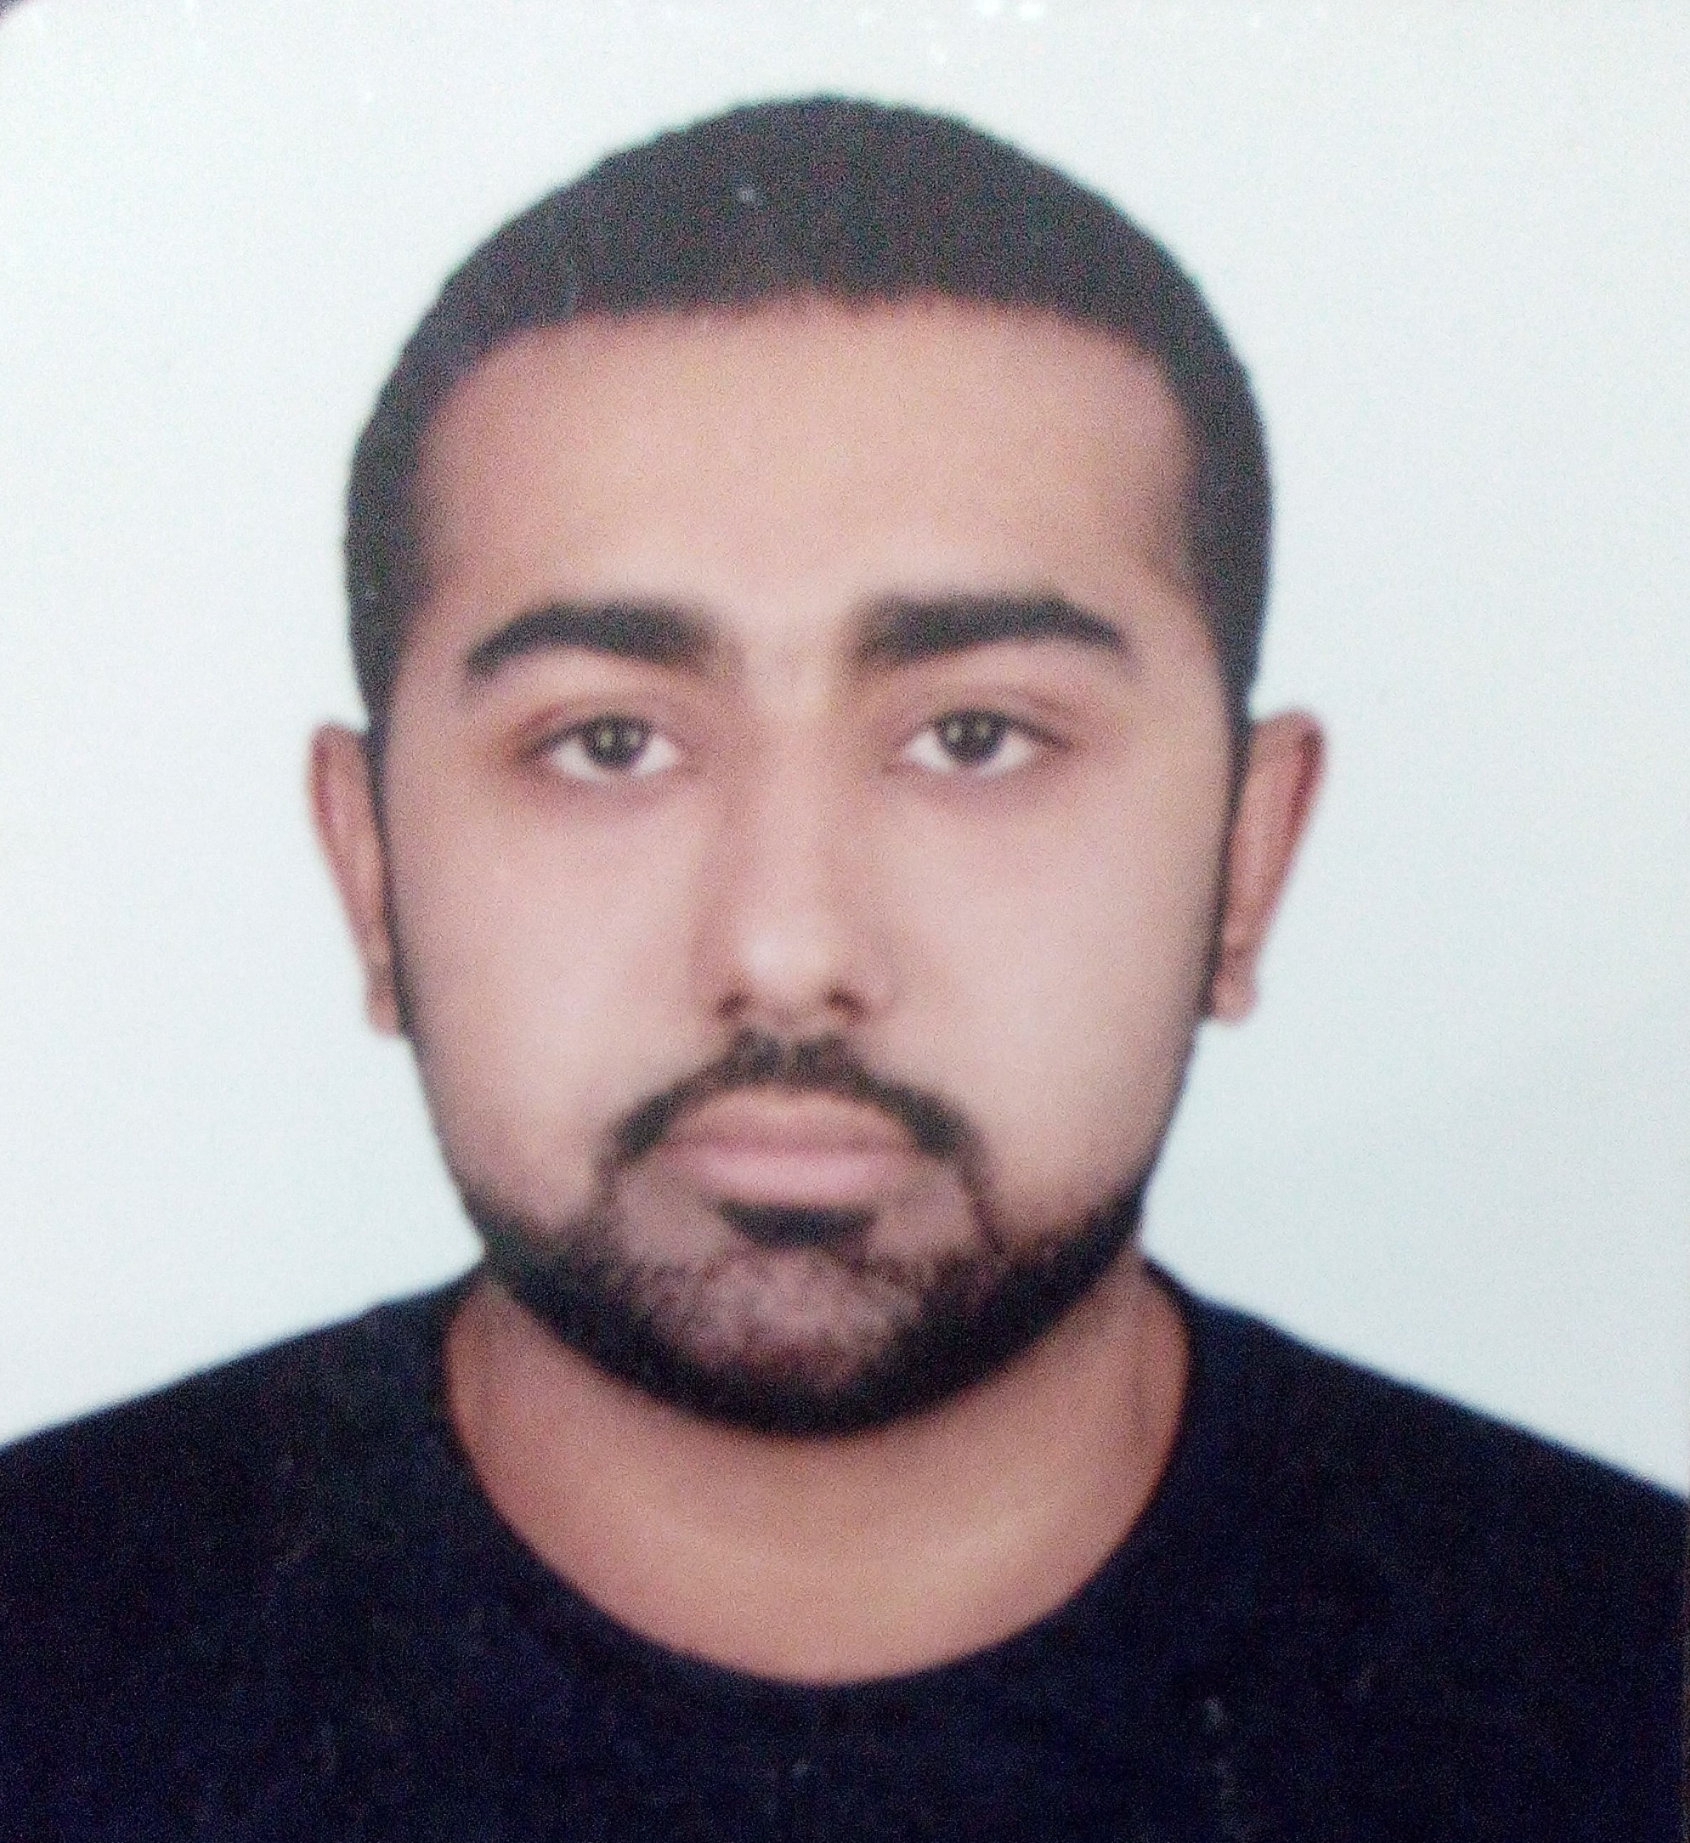

**Address: RIFFA , Bahrain**

**: +973-33786595**

✉**: janzyxxx@gmail.com**

ADEEL TARIQ

|  |  |
| --- | --- |
| OBJECTIVE | I am willing to work in a hardworking and innovative environment. My aim for the upcoming years is to work hard and establish myself as an efficient problem solver. I have great passion for work in collaboration, support & on own initiative. |
| PERSONAL | **Father Name** : **Tariq Mahmood**  **Nationality** : **Pakistani**  **Date of Birth** : **10/10/1988**  **Religion : Islam**  **Marital Status : Married**  **Passport #** : **AZ7963483**  **Visa Status : Employment** (ready to change)  **License : 881055247** (expiry 2022) |
| ACADEMICS | **DEGREE INSTITUTION**  Diploma Hotel And Catering Lincoln university Kualalumpur Malaysia  Intermediate and computer science Board of intermediate & Secondary Education, Lahore – PAK  Secondary School Certificate Board of intermediate & Secondary Education, Lahore – PAK |
| PROFESSIONAL | * Working as an **restaurant waiter** in **The Apartment Restaurant and bar** Kuala Lumpur (Malaysia)   ***PERIOD: 29STjune 2009 till Oct 2010***   * Worked as an “**Bartender”** in **The Apartment restaurant and bar** Kuala Lumpur , Malaysia   ***PERIOD: 06STMarch 2010 till Aug 2011***   * Worked as an **Restaurant supervisor** in **The Apartment restaurant and bar** In Kuala Lumpur (Malaysia)   ***PERIOD: 06ST Oct 2011 to march 2012***   * *Worked as an* ***Restaurant*** ***Manager***  *in* ***The Laundry Bar***  *in Kuala Lumpur, Malaysia*   ***PERIOD: 19Th march 2011 to Jan 2013***   * Worked as **call center agent** in **future now** Pakistan Lahore . (in PizzaPizza.ca)   ***PERIOD: 15TH Mar 2013 to Jan 2014***   * Worked at **DOUBLE TREE BY HILTON** Dubai , UAE as a **NIGHT SUPERVISOR** . ( F&B )     ***PERIOD:27th march 2014 to June 2015***   * Worked as **call center agent** in **future now** Pakistan Lahore . (in PizzaPizza.ca)   ***PERIOD: 15TH aug 2015 to feb 2016***   * Worked as **Call center agent** in **Silah gulf** under the project viva (124) Bahrain .   ***PERIOD: 20th june 2016 to june 2017***   * *Worked as* ***Salesman*** *in* ***Saleco Bahrain***  *for viva Bahrain.*   ***PERIOD: 12th july 2017 to sep 2018.***   * *Worked as* ***call center agent*** *in* ***Carriage***  *for customer service department.*   ***PERIOD: 25th nov 2018 to feb 2020.***   * *Worked as* ***partner care agent*** *in* ***hungerstation***  *for operations department.*   ***PERIOD: 1st march 2020 to present.*** |
| I. T. SKILLS | * Microsoft Access, word, excel, power point. * In page. * Internet. * Typing speed **40-45** words. |
| ACTIVITIES | * Web Browsing. * Reading Books. * Playing Cricket * Playing Badminton |
| LANGUAGES | * English (fluent) * Urdu * Punjabi * Hindi |
| STRENGTHS | * Ability to work under pressure. * Desire to learn and succeed. * Energetic and responsible |