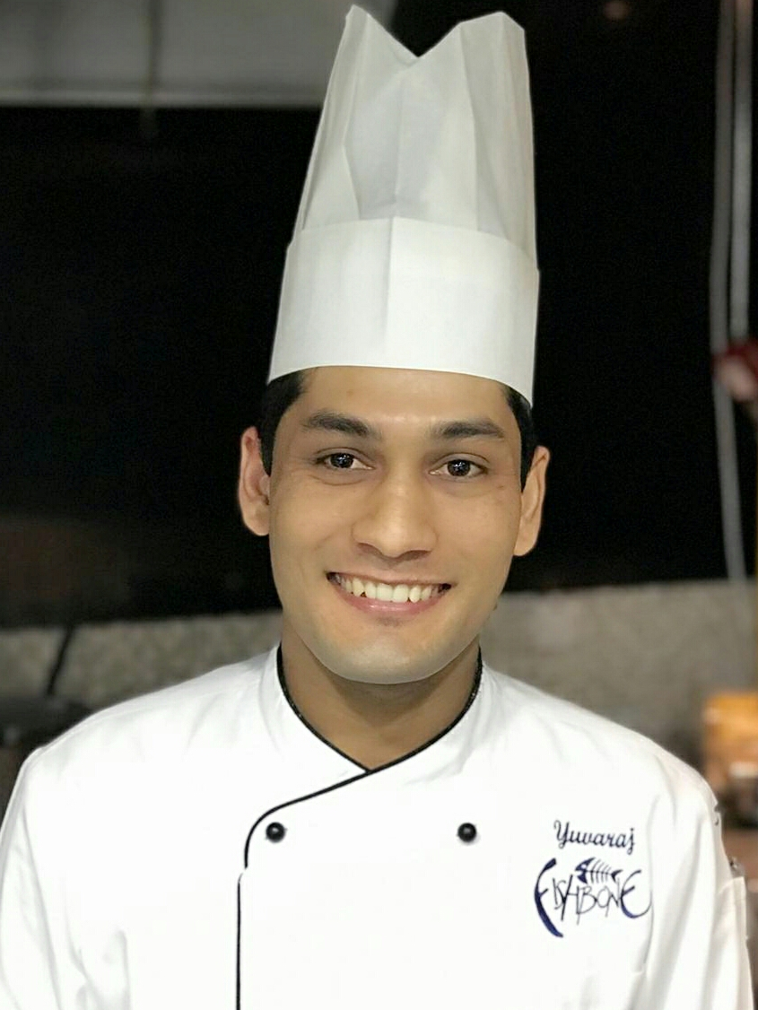
YUBA RAJ CHHETRY

Mobile No : +973 36631653

WhatsApp : +973 36631653

Email : yubarajchhetry@gmail.com

PERSONAL ATTRIBUTES

A challenging position of chef utilizing my culinary experience, integrity, professionalism and
Providing a high standard of service, knowledge and management skills that will help contribute
To the hotel’s kitchen services extensively, thus making Guest experiences a pleasant memory.

EDUCATIONAL QUALIFICATION

S.L.C – Shree Sarada Higher Secondary School: Successfully completed School Level Certificate through Nepal Board in 2008.

ADDITIONAL QUALIFICATION: computer knowledge.

WORK EXPERIENCE:

Employed : Pre-Opening at Fish Bone by chef susy massetti (Accor hotels Novotel Bharain)
Department : Italian, cold & sushi
Promotion : Chef De Partie
Duration : October 1st 2019 to till date
Job profile : Demi Chef De Partie
Duration : 4th Jun 2018 to 30th September 2019

JOB DESCRIPTION:

- In charge of the section kitchen reporting to Sous chef.
- Maintain High Standards of hygiene
- Check daily receiving items.(vegetables, meat, poultry and sea foods)
- Taking care of the ale-carte menu order and weekly brunch, daily special foods
- In addition to the day to day operation, was responsible for, ordering the supplies which include meat products, dairy, vegetables, dry stores etc.
- Was responsible for the inventory at the end of the month.
- Documentation of procedures, and product standards.
- Documentation of standard recipe cards.
- Continuous innovation of the recipes to deliver the standards of guest.
- To prepare duty roaster for the department.
- Make new gourmet food trial dishes for the restaurant
- Prepare the for set menu and take away orders.
- Making daily basis orders and handling the paper works.
- Train the junior staffs & briefly describe them about daily work pattern
- Taking care of the section kitchens operation including food quality, indent ordering, purchasing and cost controls,
- Developed action plans for hygiene standards.
- Training the staffs according to brand standards.
- Responsible for supervising, planning, coordinating and participating in the activities of personnel engaged in the preparation of italian,continental and cold cuisine.
- Supervise and coordinate with activity in cuisine.
- Preparing food items as per the Weekly brunch menu and daily special menu.
- Preparation of all basic sauces & maintain the standard of operations
- planning & implements new salads and recipe
- Check daily menus to determine the kind and quantity of food in the kitchen
- Prepare weekly time schedule.
- Inspect all food stores and refrigerated areas twice daily and suggest, where necessary, correct storage methods to comply with Health & Safety regulations
- See to it that kitchen equipment and utensils are handled and used properly and ensures cleanliness and maintenance of work area.
- Ensure that hotel cost control policies and procedures are followed.

Employed at : Pre opening at Caffe Concerto Italian Restaurant ,Doha Qater
Department : Italian, cold & sushi
Job profile : Commie Chef De Partie ( Demi Chef De Partie)
Duration : Jun 11th 2017 to 30th April 2018

JOB DESCRIPTION:

- Maintain High Standards of hygiene.
- Maintaining store and walk-in cooler as per ISO standard.
- Preparation of requisition sheet for daily store ordering.
- Taking care of Ala-crate orders for the Pasta Section, Main Course Section, Pizza section, Cold Section.
- Preparing food items as per the menu ale-carte for Breakfast,Lunch, Dinner food
- Ensuring good hygiene and health and safety at all times.
- Preparing the salads and hot food for Caffe Concerto Restaurant , Out Door, Italian Restaurant Ala-carte.
- Preparation of Italian, Continental and cold cuisine.
- Preparation Daily Paper Work.
- Ordering of dry store ingredients and butcher ingredients.

Employed at : ACCOR Group Of Hotel Novotel Hyderabad International Convention
Centre (Hyderabad India)
Department : Continental , Cold & Sushi
Job profile : Commis Chef
Duration : 5thJun 2014 to 3rdDec 2016

JOB DESCRIPTION:
- Maintain High Standards of hygiene.
- Check daily receiving items.(vegetables, meat, poultry and sea foods)
- Attend the daily morning meeting.
- Preparation daily requisition order. (Dry store, General store, vegetables, meat,poultry and sea food)
- Preparation for Lunch and Dinner Buffet for Restaurant.
- Preparation of food items as per ale-carte menu.
- Maintaining store and walk-in cooler as per ISO standard.
- Guide to reliever about operation.
- Handling the guest & guest reviews.

Employed at : Green Park Hotel Hyderabad.(INDIA)
Department : Kitchen
Job profile : Commis 2nd
Duration : 3rd May 2012 to 6th Feb 2014

JOB DESCRIPTION:

- Maintain High Standards of hygiene.
- Maintaining store and walk-in cooler as per ISO standard.
- Preparation of ordering shit for daily store ordering.
- Not only taking care of Hot Buffet also handling the guest.
- Taking care of Ala-carte orders for Room service and restaurant.
- Preparing food items as per the menu for restaurant Hot Buffet.
- Ensuring good hygiene and health and safety at all time.

Employed at : Anchor Restaurant (Chennai ,INDIA)
Department : Kitchen
Job profile : 3rd Commis
Duration : 15 Jun 2010 to 25th April 2012

JOB DESCRIPTION:

- Ensuring good hygiene and health and safety at all times.
- Maintain store and walk-in cooler as per ISO standard.
- Preparation Lunch and Dinner for Restaurant.
- Preparing the Ala-carte set up and prepare Ala-carte order.
- Sotre pickup and vegetable pickup .
- Maintain the all records.

Employed at : Taj Tristar (Hyderabad ,INDIA)
Department : Kitchen
Job profile : Trainee
Duration : 8th Jan 2010 to 12th Jun 2010

JOB DESCRIPTION:

- Ensuring good hygiene and health and safety at all times.
- Maintain store and walk-in cooler as per ISO standard.
- Preparation mise en place .
- Preparing the Ala-carte set up & help to chefs.
- Sotre pickup and vegetable pickup setup.

PROFESSIONAL TRANNING:

- HACCP And Hygiene
- Fire Fighting
- Kitchen Sanitary
- First Aid

PROFESSIONAL SHOWCASE

- Excellent interpersonal skills, motivational and executing promotional skills.
- Superb customer relation skills, quality assurance & control.
- Great ability in cost control, problem solving ability to analyse issues, creates plans of action and reach solutions.
- Exercise initiative in conducting food surveys, achievement and independent judgment in sourcing and approving new products.
- Develop kitchen processes in respect of team building.

PERSONAL DETAILS

Date of Birth : 1st May 1992
Nationality : Nepalese
Status : Single
Gender : Male.
Hobbies : Listening to music, riding bike, playing volley ball, travelling.
Languages known : English, Hindi, Bangali ,Tamil & Telugu.
Passport Number : 06894600
Passport issued : 18 Dec 2013.
Passport Expiry : 17 Dec 2023.

