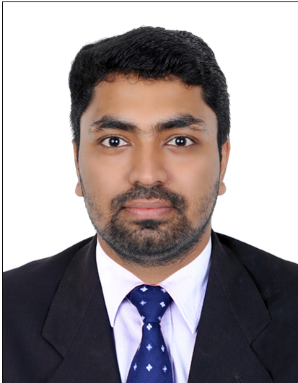 |  | Dinoop Gopalan  Senior Retail Executive
Profile  Diligent, proactive retail sales associative with hands-on experience in effective merchandise presentation and persuasive selling skills. My 4.8 years of sales experience can be fully utilized to improve sales bottom line and the company revenues.  Contact  Phone 973-33752583  Email dinoop195@gmail.com  Basic Info  CPR : 910532591  Marital : Married  Nationality : Indian  Languages : English, Hindi,  Malayalam, Tamil  HIGHLIGHTS  - Strong Communication Skill  - Cash Handling Accuracy  - Organized  - Time Management  - Inventory Control  - Proficient in MS Office  - Knowledge of ERP tools  - Knowledge of SAP |  | EDUCATION  Doing Bachelor of Business Administration (BBA)  Diploma in engineering MPTC Vadakara, India 2011  Higher Secondary K.K.M.G.H.S.S, Orkkatteri, India 2008  SSLC K.K.M.G.H.S.S, Orkkatteri, India 2006  WORK EXPERIENCE  Sharaf DG Retail Executive  OCT 2015 – Present  Responsibilities:  - Good organization skills with the ability to handle multiple tasks such as Cashier and Retail Sales.  - Ensure proper coverage and availability of products  - Follow up to new policy and Company promotion  - Meeting up proper quarterly appraisal percentage, and gaining above 90% of sales target  - Helps customer make selections by building customer confidence, offering suggestions and opinions  - Ensure implementation of the Plano-gram on all products  - Follow up the product ageing list accordingly to sale priority  - Arranging my correspondent department with  up to date price and stocks

HCL Services Ltd ,INDIA System Administrator
May 2011 – June 2015

Responsibilities

- Installing and configuring desktop, printer, accessories
- Handling site support
- Handling windows and VMware
- Handling customer issue and solving
- Network configuration and troubleshooting
Personal details
Date of Birth : 19 – May – 1991
Gender : Male
Passport No : J7621929
Address : Flat #21, Building#2539, RD#2138, Blk#321, Gudaibiya
Bahrain driving license : Yes

Declaration
I hereby declare that all the details furnished above are true to the best of my
Knowledge and belief.

