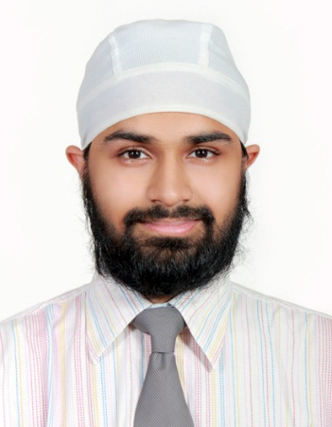

|  |
| --- |
| Satprit singh khurana  D.O.B. – 05th December 1989  Gudaibiya, Manama · 39066933  wvimpy@hotmail.com · <https://www.linkedin.com/in/satprit-singh-khurana-390114a8/> |
| 1. Secure a responsible career opportunity to fully utilize My training and skills, while making a significant contribution to the success of the company. |

# Experience

|  |
| --- |
| March 2018 – currentsenior customer care specialists, sadad electronic payment system bsc Responding to customer queries in a timely and accurate way, via phone, email or chat  Identifying customer needs and helping customers use specific features  Analysing and reporting product malfunctions  Carefully assessing, Checking the submitted profiles of the Users and activating them as per the laid protocols.  Assuring the quality of the activated profiles by auditing the details. |
| June 2011 – march 2018Administrative manager, jannat trading centre Basic Management of the Shop  Making sure the right amount of inventory is maintained and placing order on items that are short.  Sales and Marketing of current as well as new Products available with the shop. April 2008 – may 2008car salesperson, Galaxy motors (mumbai) Member of the sales team of the dealership.  Was successful in selling 2 cars in a span of a month. |
|  |

# Education

|  |
| --- |
| January 2013Masters of business administration (marketing), Sikkim manipal university (distant education) |
| june 2009Bachelors of commerce, mmk college (mumbai) |

# Skills

|  |  |
| --- | --- |
| * Strong and Good Communication Skills * Ability to work under pressure | * Adaptability * Self-Motivation * Organized * Time Management |

# Activities

Achieved various trophies and Medals in Cricket, Football. Still currently representing clubs in cricket. Other Sports interested are Tennis, Table Tennis, Billiards.

An Avid gamer from a very young age.

Was part of the Young Orators Gavels Club. Serving as Sargent at Arms, Treasurer, Vice President.