 | LAISHAJ BASHEER MOHAMMED  Manama, Kingdom of Bahrain CPR No : 880583983  Email :Laishaj@gmail.com Passport No: H8666873  Phone :+973-36592505 Nationality : Indian | 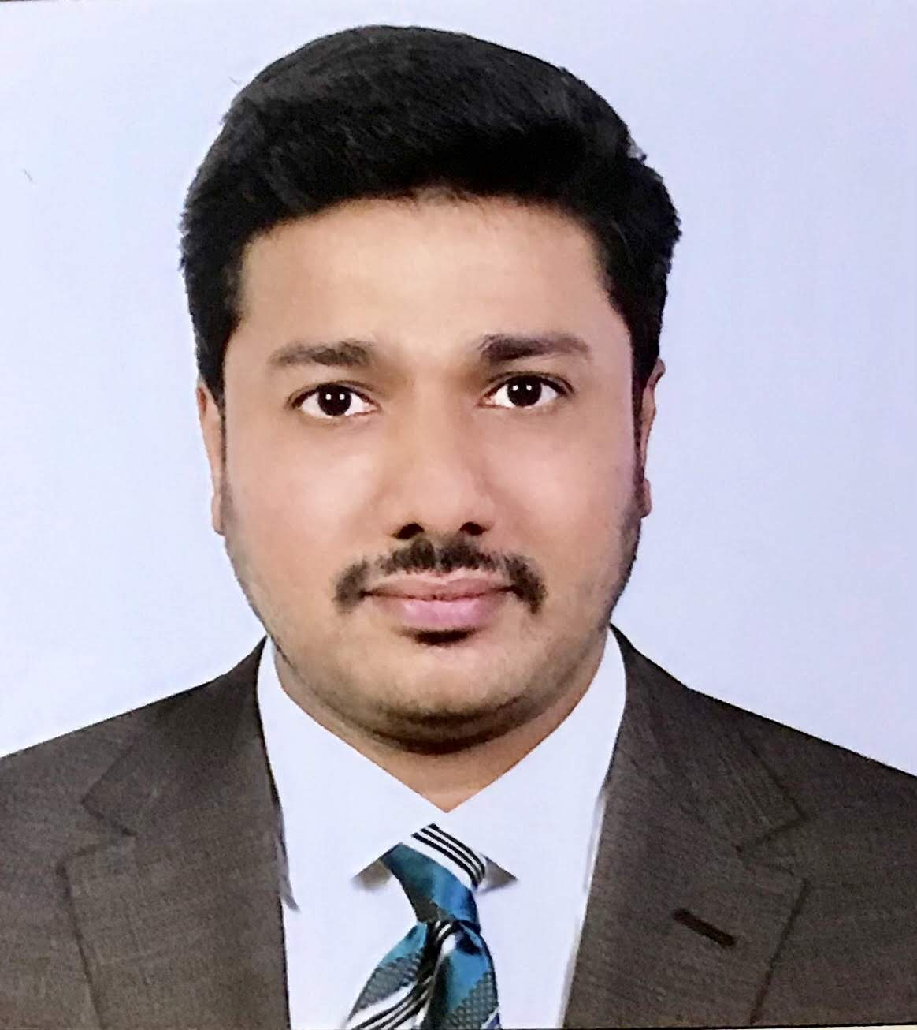
Objectives
Seeking a challenging career in a progressive organization, shoulder the responsibilities and to work for the organization’s satisfactions in the job assigned to, and grow along with the organization stretching myself to develop new abilities.

Career Experiences:

Experienced in Business Consultancy Services more than 4 years
in the Kingdom of Bahrain - Company Formation works, Business advisory

- OFFICE ADMIN
B.Max Business Bureau WLL- Manama, Kingdom of Bahrain
( 2018-2020 )
- BUSINESS CONSULTANT
MANAMA BUSINESS PARK WLL – Manama ,Kingdom of Bahrain
(2016-2018)
Company Formation works & Lmra works
Corporate management & Advisory
HR & Recruitments
Other official document clearance
- OFFICE ADMIN
At MOON LIGHT MEDIA CO W.LL, Manama, Bahrain
From 10/01/2016 to 05/09/2016
- DOCUMENT CONTROLLER
At KABBANI TRADING CENTER Riyadh, Saudi Arabia
From 12/02/2013 to 28/03/2015
Maintain tracking database of - controlled – documents
- TECHNICAL ASSISTANT
At SIDCO TOOLS.( A Government Organization) Kerala, India
From 2012 to 2013
Its manufacturing company of Jigs and Fixtures, Developing Precision
components for ISRO (Indian Space Research Organization).
Academic Profile:

- B.Tech in Mechanical Engineering
Vinayaka Missions University
Salem,Tamil Nadu - 2012
- Secondary School Education
+2 State Board Of Secondary Education
Kerala -2015
- School Education
State council for educational research
Kerala – 2003
- Auto CAD – Mechanical
2D &3D Cadd center,Kerala
- Technical Education
A.S.N.T Level 2 certification in NDT
(Non Destructive Testing)
In Magnetic particle Testing, Penetrant testing,
Ultrasonic Testing, Radiographic Testing

System Knowledge:

- MS Office,
- Adobe Photoshop,
- AutoCAD
- Hardware installation and networking, software installation,
Installing operating systems

Languages
- English
- Arabic
- Hindi
- Malayalam
- Tamil

Personal Details
- Date Of Birth : 31-05-1988
- Gender : Male
- Marital Status : Single
- Nationality : Indian
- Father’s Name : Abdul Basheer
- Passport No. : H 8666873
- Permanent Address : Sumayyas, Thevalakara PO
Kollam, Kerala, India

Declaration

All the information gives above are true to the best of my knowledge and believe.

Manama Laishaj.BM

