**Curriculum Vitae**

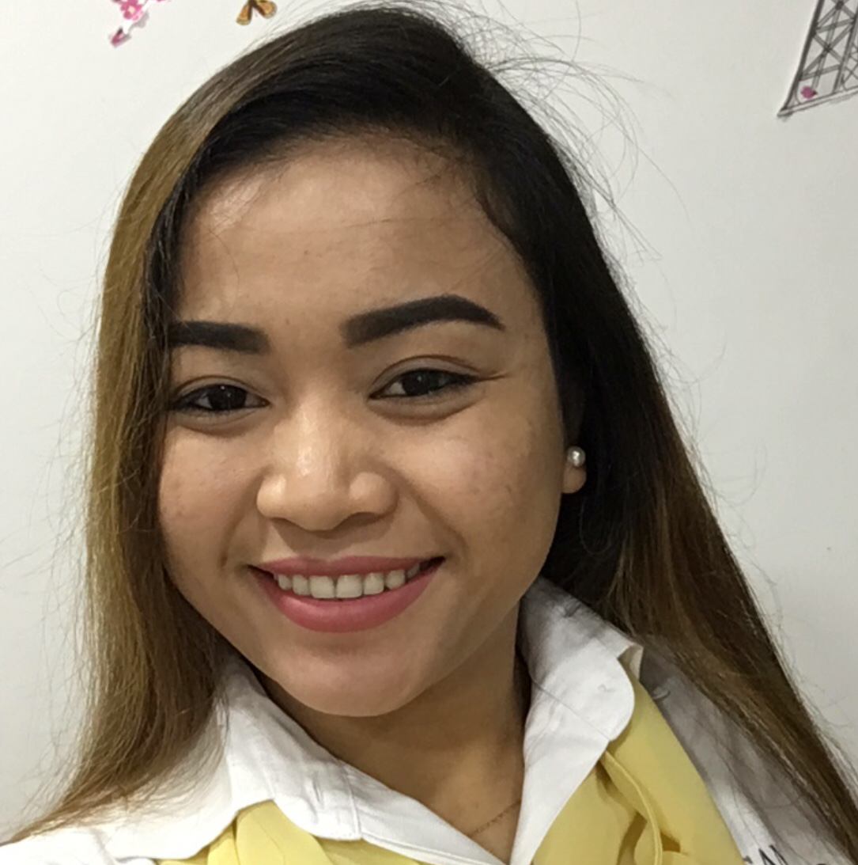

**PRINCESS D. BACO**

* **Address: Flat 1, Building 241, Road 906, block109 hidd**

**Kingdom of Bahrain**

**Mobile No.: 66697888**

**E-mail Add:** [princessmikay@gmail.com](mailto:princessmikay@gmail.com)

**JOB OBJECTIVE:**

To be part of a company that offers challenging job opportunity that will utilize my knowledge, experiences and skills in various field of interest.

**PERSONAL DETAILS:**

Date of Birth: November 18, 1997

Nationality: Filipino

Age: 20

Sex: Female

Civil Status: Single

Religion: Roman Catholic

Language Spoken: Filipino, English, Hiligay-non, Arabic

**EDUCATIONAL BACKGROUND**

Tertiary: West Visayas State University-Pototan Campus

Bachelor of Science in Information System

Secondary: Pototan National Comprehensive High School

Elementary: Rizal Elementary School

**WORKING EXPERIENCES:**

* Worked as a Waitress and Cashier in Sanremo Cafe in Amwaj Islands from **December 1, 2017** to **July 30, 2018**.

• •Worked as a Sales Lady at Mr. Price in Galali, Kingdom of Bahrain From **August 15,2016** to **November 18,2017.**

**Duties:** Assists and informs customers about a product being sold.

* Worked as a Waitress and Cashier for three years at **Josephines Restaurant** in Pototan, Iloilo, Philippines **since May 16, 2011 to March 8, 2014.**

**Duties:** Assisting customers, Taking orders, Delivering the orders and Receive payments and present change to customers.

* Worked as a Merchandiser at **Asia Novo** in Pototan, Iloilo, Philippines from **March 30, 2015, to March 30, 2016**.

**Duties:** Promote products and assists the customers.