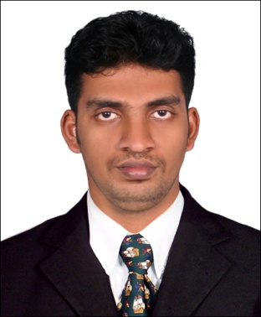  NAME:D.V.BIBIN  ADDRESS FOR CORRESPONDENCE  3/9BTHANIVILAI VEEDU, MUNCHARAI PUTHUKADAI (PO) KANYA KUMARI (DT)TAMIL NADU-629171 INDIA  Mobile :33097280  Watsapp: +918056928097  +97333097280  Email ID: dvbibin@gmail.com  dvbibin20@gmail.com  Passport no:k8965715  Personal Profile  Date of Birth:  9thNovember1989  Father:DHAMODHARAN  Mother:VIJAYAM  Gender : Male  Nationality : Indian  Marital Status: Single | CURRICULUM VITAE  CAREER OBJECTIVE  Seeking a position to utilize my skills and abilities in a company that offers professional growth while being resourceful, innovative and serviceable, also good communication skills, interpersonal skills and fast learning abilities.  Myselfwitha  WORK EXPERIENCE  1.Serco Global Services was worked in the company as “ Customer Service Associate”in Grade E01 at Bangalore Location from 25thjune 2012 to 19th August.  co 2.Completed training as a Trainee Technical Assistant in Quality Control and Technical Services in Air India Express Engineering, MRO Facility, (Boeing 737-800 NG aircrafts), Trivandrum, Kerala.  Wo rk Work Description  - Coordinates timing of purchase, acceptance and routing of materials based on program needs  - Drive material quality for programs through inspections, analysis, and testing  - Making of consumables, tools and expendable’s list as per Boeing Task Cards.  - Ensure materials are ready and available for programs and Controls excess, insufficient, or deficient materials.  - Maintaining proper coordination with Aircraft Tool Store, Bonded Store and Maintenance Department.  - Man Hour review is done in every two months and corresponding list to be made for the meeting relating man hour.  3.Worked as Real communication in Reliance company “Store manager at Trivandrum Location from 1st september2012 to 30stjune 2014.  4. Worked employee as” Market xcel Data matrix pvt ltd” in designation RM(Relationship manager) at Trivandrum location from 10th January to 10th October 2018.  5. Worked onroll employee as Reliance rcom company in designation CSO(caf signed officier).  2.  WORR
Work Description

- Independently responsible for acceptance / rejection of customer activation based on his own judgment in line with laid down regulatory requirements.
- Responsible for physical signoff of all activations (ensure all the checks and processes are carried out and mandatory fields in the Customer Acquisition Form (CAF) are filled before sign-off).
- Oversee service provider staff.
- Do random sample audit of Data Entry, Scanning, and dispatch of the forms to Circle/Zonal Warehouse.
- Report any discrepancies on a daily basis to ZCSH, Partner and Circle Activation Lead.

EDUCATIONAL QUALIFICATION
Academic Qualification | Name of the Institution | Board/University | Year of Passing | Percentage
B.E.(Aeronautical Engineering) | PSN College of Engineering and Technology | Anna University | 2011 | 73%
HSC | GOV Higher Secondary School, Muncharai | State Board | 2007 | 67%
SSLC | KABDM Higher SecondarySchool, Painkulam. | Matriculation Board | 2005 | 62%

TECHNICAL SKILLS

OTHERS: Fair knowledge in Internet and MS Office

PERSONAL SKILLS

- Comprehensive problem solving abilities.
- Ability to deal with people diplomatically.
- Willingness to learn, team facilitator, hard worker.

HOBBIES
- Playing Cricket, Internet Browsing and shopping.
- Personal hobby is listening music.

DECALARATION
I hereby declare that the above particulars given are true to the best of my knowledge and belief.
Place: Yours sincerely,
Date: [D.V.BIBIN]

