Curriculum Vitae

**Sabita Bade** 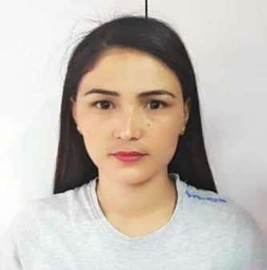

**Manama**

**Kingdom of Bahrain**

**Mob: +973 37787420**

**Email: sabitabade3@gmail.com**

**Application for the post of beautician**

**Career Objective:**

To purse my career in a challenging and dynamic envieonment where my skills and

Capabilities could be most utilized & there by to become a part of success of the

Organization.

**PERSONAL DATA**

Name of Father **: Kanchha Bade**

**Date of Birth : 17-02-1992**

Sex **:** Female

Civil Status **:** UnMaried

Nationality **:** Nepalise

Religion **: Hindu**

Language Known **:** English, Hindi, Arabic and Nepali

**PASSPORT & CPR DATA**

Passport No **:** 08595886

Issue Date **:** 12-02-2015

Expiry Date **:** 11-002-2025

C.P.R No **:** 920241409

**EDUCATIONAL BACKGROUND**

* **S L C** School Leaving Certificate

1. **WORKING EXPERIENCE IN BAHRAIN**

* Presently working as beautician in LE COIFFURE BEAUTY SALOON Bahrain **from**

2017ToTill

* Holding 2 Years of Experience in Sakura Beauty Saloon and Traning Center in KTMNepal As a Beautician

**SKILLS**

* Threading, Face Wax, Body Wax, Hair Treatment, Hair Protien, Body Massage,Manicure, Pedicure, Hair Cut, Hair Henna, Hair Style

**DECLARATION**

I hereby declare that all the information that is mentioned above is true to the best of my knowledge and belief.

**KINGDOM OF BAHRAIN SABITA BADE**