**Salman Mohammed Rafiq** 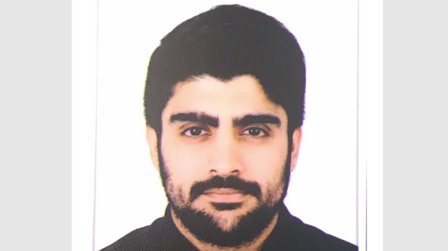

[salman.alblushi@icloud.com](mailto:salman.alblushi@icloud.com)

**Contact**

Hoora, Exhibition Road, Block 318, Road 1813, Building 1014, Flat 11

Phone: 97366759366

**Career Objective**

A Self-motivated, bright and confident university leaver who is able to work closely with various stakeholders to ensure a timely and efficient recruitment process in any department. I have superb communication skills and can quickly establish working relationships with a range of stakeholders at all levels. I am keen for new experiences and willing to accept new challenges. Right now, I am looking for an entry level position in your organization from which I can launch my career and prove myself.

**Education**

**Bachelor of Laws 2015 — 2020**

University of Bahrain

Ahmed Al Oomran Boys Secondary School

**Interests**

Electronics, Explore new ideas, Sports, Art, Gaming, Pet care, Reading

**Key Skills**

Excellent interpersonal and communication skills, organization skills, teamwork, self-motivation, passion, willingness to learn, integrity, conscientious, decision making, analytical mindset, creativity, ability to multitask and work under pressure and adaptability.

**Languages**

1. Arabic
2. English
3. Balochi
4. Urdu
5. Hindi

**References**

References available upon request.