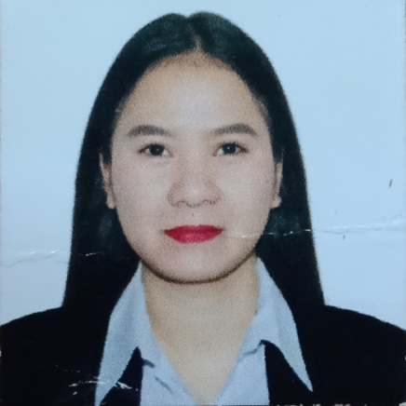

**Lovely Osorman Herrera**

Present Address: Bldg 38A, Road # 1176 Blk 917 P.O Box 40177 East Riffa, Kingdom of Bahrain

Permanent Address: #**9C CALLEJON ROSAS ST. Kapasigan, Pasig City 1606,**

Tel No.: **33138715**

osorman08@gmail.com

**OBJECTIVE:** My goal is to become associated with a company where I can utilize my skills and gain further experience while enhancing the company’s productivity and reputation.

**PERSONAL DATA**

Date of Birth :           August 20, 1994

Place of Birth :           Pasig City

Age : 25

Sex : Female

Marital Status : Single

Nationality : Philippines

Passport Number : P3425082B

CPR number : 940843269

Language : English – Good Speaking, Reading, &

Writing

**EDUCATIONAL BACKGROUND:**

**College Level -** AMA Computer University - Pasig Campus

San Miguel Ave, Ortigas Center, Pasig, 1605 Metro Manila, Philippines

Year Graduated (2010 – 2014)

Course: ***Bachelor of Science in Hotel Restaurant Management***

**Secondary -** ***Rizal High School***

Caniogan, Pasig City

Year Graduated (2006-2010)

**Primary -** ***Pasig Central Elementary School***

Pasig City

Year Graduated (2000-2006)

**SKILLS:**

* Work Confidently with the group
* Fast Learner
* Ability to work under pressure
* Love the challenge of trying new things
* Able to motivate and direct others
* Hard working
* Flexible
* Willing to learn more and be trained for the new field
* Willing to do multi-tasking

**WORKING EXPERIENCE:**

***Mezza House Sar***

Alazzam Group of Company

December 2019 to Present

Kingdom of Bahrain

***Barista***

*Duties and Responsibilities*

* Handle cash, credit or check transactions with customers
* Count money in cash drawers at the beginning and end of shifts to ensure that amounts are correct and that there is adequate change
* Greet customers when entering or leaving establishment

***Zippy Grand Café***

*February 2018 to November 2019*

4 P.Burgos St.San Jose, Pasig City PH

***Waitress and Barista***

*Duties and Responsibilities*

* Greet customers when entering or leaving establishment
* Welcoming customers
* Preparing foods
* Informing them about specials or new items
* Answering questions, and accepting orders and payments

***HostPro Property Management***

*August 2016 to March 2018*

2th Floor, The Trade and Financial Tower, 7th Ave and 32nd Street, Bonifacio Global City, 1634 Taguig

***Operation Supervisor***

*Duties and Responsibilities*

* Ensure compliance with applicable laws and company policies.
* Supervise everyday working of department operating process and increase efficiency of workers for various growth oriented programs.
* Supervise effective compilation and collection of information and data to enhance growth

***LAVA TIMOG Resto***

May 7, 2015 to July 5, 2016 Timog avenue, Quezon City, PH

***Waitress and Cashier***

*Duties and Responsibilities*

* Take accurate food and drink orders using a POS system and communicate order details to the kitchen staff as needed.
* Check customer’s ID if necessary to assure they are of legal drinking age.
* Inform guests about restaurant customer loyalty program, or any other specials and promotions.
* Up-sell any additional products when appropriate.
* Serve food and drink orders to guests.
* Present and pour wine selections with the appropriate stemware.
* Stay up to date on any menu changes and daily specials.

**Wellness Connect (New Zealand)**

October 8, 2014 April 10, 2015

SM North Annex- Quezon City, PH

***Sales Lady***

*Duties and Responsibilities*

* Customer Communication. Communicating with customers is a broad category that includes welcoming customers, assessing the customer's needs and answering any questions that the customer may have. ...
* Assisting Customers
* Complete Financial Transactions
* Demonstrate Product Knowledge

**CHARACTER REFERENCES:**

**MERCY CHATEAU BEAUTY SALON**

***Owner***

Bldg # 123 Abdulla Centre Road #3306, Riffa 933 Al Buhair Kingdom of Bahrain

+97339650023

**Alazzam Group of Company**

***Head Office Department***

3 Palmera Building, P.O. Box 15608 432 Shiekh Isa Ave. Adliyah Kingdom of Bahrain

+97317717730

**AMSA DOCUMENTS AND COMMISSION**

***Executive Manager***

Shop 36 Bldg 38A, Road #017 Blk 917 Riffa Bukwarah, Kingdom of Bahrain

+97313651155

*I hereby certify that the above information is true and correct to the best of my knowledge and belief.*

Signature