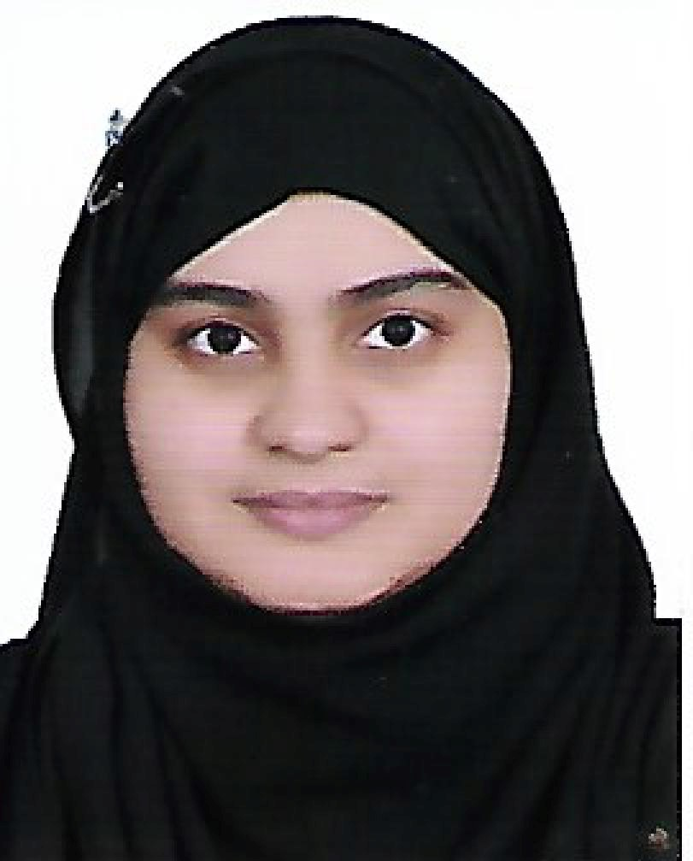 |  |  |  | Areej  Javed

Career Objective:
Energetic and passionate university student in B.Sc. Biochemistry. Aiming to use my knowledge of my major in all ways lead to science.

Education
B.Sc. Biology with minor Chemistry, University of Bahrain 2014-2020
- Undergraduate student currently enrolled in University.

Internship
Completed the internship at Ministry of Works, Sanitary Engineering and Maintenance organization Division (SEMOD), Tubli, Bahrain. From 30/06/2019 to 29/08/2019.

Workshops, Submits and Conferences
The Millennium Biotechnology Pan Arab Conference & Bio-Business Form
23-24 April 2019

Material Science Between Theory and Applications. Chemistry Symposium. 10-11 April 2019

Waste management symposium. UK – Bahrain waste management symposium. 16-17 February 2020

Computer programs:

Microsoft word, excel, power point and SPSS.

University Projects
Biols 222: Plant Morphology
Identified different plant species and the plant parts that take part in different process including plant cell processes.
Biols 250: Microbiology
Learned aseptic techniques and working on bacterial cell culture and growing pure bacterial colonies in laboratory.
Biols 234: Chordate Zoology
Identifying different species of Chordates and their dissection for detailed internal morphology.

Biols 232: Invertebrate zoology
Identifying different species of invertebrates and their dissection for detailed internal morphology.
Biols 320: Plant Physiology
Growing plants in different cultures and identifying the nutrients that are deficient in those plants.
Biols 340: General Ecology
Visited different parts of Bahrain for detailed ecological analysis. Collected samples of soil and plants from different parts and conducted studies on them to count the plant population and contents present in the sample that could be of harm.
Chemy 211: Analytical Chemistry
Skilled in analytical analyses of organic and inorganic substances.
Biols 380: Marine Biology
Collected different samples from sea and beaches located in Bahrain and performed detailed analyses on them that include pH, live forms count, identifying the different species and presenting the results as a scientific presentation in front on invited scientist guests.
Biols 465: Gene Technology
Growing pure bacterial cultures and performing gene technology on them to extract DNA and modify the DNA and analyzing the results using electrophoresis technology.
Biols 404: Biotechnology
Isolation of bacteria from soil and its study for the antibiotics production.

 |  | Building 661, Flat 12, Road 321, Block 103, Hidd, Bahrain.
 |  | (+973)33276855
 |  | Aieshko94@gmail.com
Nationality : Bahraini

Language : fluent in English and Urdu.

SKILLS :
o Problem Solving
o Research
o Communication
o Strong Work Ethic
o Time Management
o Critical Thinking
o Handling Pressure
o Leadership
- Group work and cooperation

