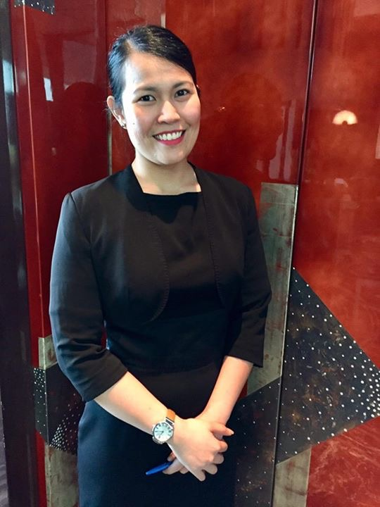**Ebony D. dela Calzada**

Bldg. 4540, Rd. 2466, blk 324, Enjaz Residences, Juffair, Bahrain

+973 66660032

Whatsapp: +973 36788747

[ebonydelacalzada@yahoo.com](mailto:ebonydelacalzada@yahoo.com)

Citizenship: Filipino

——————————————————————————————————————————

**DESIRED POSITION:** F&B Service, Receptionist, Front Office, Customer Service

**SKILLS AND COMPETENCIES:**

* Knowledgeable about wines and F&B services
* Mixes cocktails and cocktails and makes coffee
* Knowledgeable about hostess job
* Effective Concierge Agent and knows how to check in and check out
* Good English communication skills both oral and written
* Computer literate and knows how to use the OPERA system
* Flexible and willing to be trained

**PROFESSIONAL EXPERIENCE:**

**Four Seasons Hotel Bahrain Bay (Pre-opening Team)**

**Concierge Agent (January 2018 – June 2020)**

* Concierge is the only job that has no exact definition.
* We assist the guest for restaurant reccommendations, tour bookings and arrange the transportation.
* We aslo do our best to meet the guest needs and even do almost impossible guest request.
* We have to go extra mile for any special request to make the stay more memorable and exceed guest expectations.

**F&B service in CUT by Wolfgang Puck (Pre-opening Feb 2015- December 2017)**

* Reliever of the Hostess
* Responsible in preparing the beverage of the guests especially coffees, teas, wines and other bottled beverages and selection of breads.
* In-charge of the service bar station and bread station in the restaurant.
* In-charge of the wines by the glass use in wine pairings
* Assisting the runners in running the foods

**Cucina Italiana Bahrain**

**Bartender/Barista (August 2014-February 2015)**

* Responsible of making the all drinks such as coffees, cocktails, mocktails, wines and beers for the guests.
* In-charge for inventory everyday, weekly, and month-end. And also for reordering the stocks of spirits, wines, beers or anything that needed in the bar.

**Kazbah Catering Bahrain**

**Food server/ Office girl in *National Motor Company* (August 2013- August 2014)**

* Reliever of the receptionist
* Responsible for making and serving the coffee & tea for the customers and staffs in the GM showroom
* Serving the lunch buffet

**INTERNSHIP*:***

***Best Western Oxford Suites Makati*** June 19, 2012-October 6, 2012

518 P. Burgos Street, Makati City, Philippines

* *F&B, Finance, Front Office, Sales & Marketing and Housekeeping Departments*

***Don Henrico’s Ristorante*** November 9, 2010-Janunary 13, 2011

Festival Mall, Alabang, Muntinlupa City, Philippines

* *Kitchen assistant and Food server*

**EDUCATIONAL ATTAINMENT and AFFILIATIONS:**

**BAHRAIN CONCIERGE GROUP**

***Affiliated to Les Clefs d’Or UAE***

***Wine and Spirit Education Trust***

**Level 2 Award in Wine and Spirit**

Wine Story Academy Shangri-la Plaza EDSA, Mandaluyong City, Philippines

S.Y: 2016

***University of Perpetual Help System***

**Bachelor of Science in Hotel and Restaurant Management**

Sto. Niño, Biñan, Laguna, Philippines

S.Y. 2009-2013

**AWARDS/HONORS:**

* Passed the **WSET level 2** with merits passed with distinction
* Employee of the month in September 2015 and April 2017
* Graduated as Cum Laude

**CHARACTER REFERENCES:**

**Fabio Marques +973 35923875 Ali Radhi**

***Director of CUT by Wolfgang Puck Concierge Supervisor***

*I hereby certify that the above information are true and correct to my best knowledge and belief.*