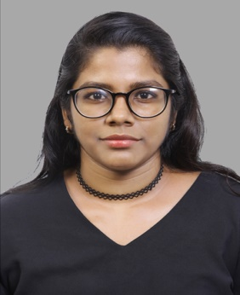C:\Users\Roshni\Desktop\phone final.png**AISWARYA S**

**C:\Users\Roshni\Desktop\mail final.png973 38406913**

[**aiswaryab67@gmail.com**](mailto:aiswaryab67@gmail.com)

**Summary:**

A Proactive individual with a passion in computer networking and cyber-security. A BCA graduate and Cisco Certified Network Associate in Routing and Switching.

Key strengths include connectivity and core routing with cisco devices; well-honed communication and research skills. Possess an innovative acumen to explore and work with new technologies and network security concepts. Seeking a challenging role as Associate Network Administrator, Network Associate, Systems Admin or IT support.

|  |  |  |  |  |
| --- | --- | --- | --- | --- |
| **Academic Profile:** | | | | |
| **Qualification** | **University/Board** | **Institution** | **Overall Score** | **Year** |
| Cisco Certified Network Associate (CCNA:RS) | Cisco Systems Inc. | Aptech Training Institute,Bahrain | 91% | Oct 2020 |
| Bachelors in Computer Applications | Calicut University | St. Thomas College, India | 70% | 2016-2019 |

**Key Skills & Achievements:**

* **Technical Skills:**  Achieved Cisco certification CCNA R&S in Routing and Switching. with hands on lab experience with Cisco routers and catalyst switches.
* Installing and configuring computer networks and OS using VMware
* Maininting existing software and hardware, upgrading and taking back-ups
* Knowledge on solarwinds used to scan networks for potential issues.
* Automation, high availability ,fast convergence, ip services, network access, security
* **Reasoning & Analytical Skills**:Problem-solving, interpersonal,teamwork, attention to details.

**Personal Details:**

* Date & Place of Birth: 29 March, 1998 (Kingdom of Bahrain)
* Nationality: Indian
* Language: Efficient in verbal and written communications in English and Hindi
* References: Will be made available upon request

**Declaration**:

I do hereby declare that the above furnished information is true and correct to the best of my knowledge and belief.

**Digital Badges:**

