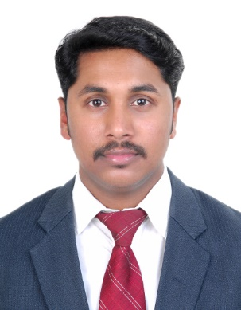  SARATH PR  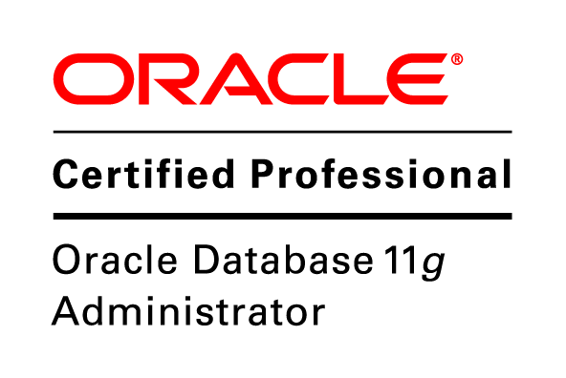  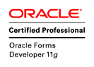      E-mail:  sarath777@gmail.com  Address:  Flat 3, Building 2435,  Road 2134, Block 321,  Manama, Bahrain  Contact no.:  Bahrain : 97333763415  WhatsApp : 97333763415  India : 919895333192  Skype : sarathpr777  Driving License:  Indian, Bahrain | Career Objective:  To be a part of an esteemed organization and prove myself dedicated, worthwhile and energetic in the field given to me, which gives me scope to apply my knowledge and skills to the best and dynamically work towards the success and growth of the organization.  I believe that my zest and zeal for working and succeeding will make me an asset to any organization.  Professional Summary:  - 12+ years of experience in IT Industry as Group Leader and Technical Trainer.  - Handled different Software Technologies, MIS and Accounting Packages.  - Hands on experience in delivering technical training.  - Extensive experience in Oracle & SQL Server Database design, Database maintenance, Backup & Restore, Import & Export, Developing T-SQL queries, stored procedures and triggers using SQL Server 2005/2008/2012/2014/2016 and Oracle 9i, 10g, 11g, 12c.  Vendor Certifications:  - Oracle Certified Professional (11g Administrator)  - Oracle Certified Professional (11g Forms Developer)  - Oracle Certified Associate (11g Developer)  - Microsoft Certified Solution Associate (SQL 2016 Development)  - Microsoft Certified Trainer 2020  - GNIIT (3 Year Computer Diploma Course of NIIT)  Working Experience  - Two year and three months Experience in Substation.
Experience Summary

Period : September 2019 to till date
Organization : Training Plus Institute, Bahrain
Designation : Microsoft Consultant – IT Trainer
Training Plus Institute (TPI) was formerly known as New Horizons Computer Learning Center and founded in The Kingdom of Bahrain in 1996. Training Plus Institute is the recognized leader in Training technology and customized solutions for enhanced organizational performance. The Institute is specialized in Training and Development of IT and Management Skills.

Roles and Responsibilities:

- Imparting Corporate Training and assisting clients in their real time projects.
- Handling Tamkeen Batches.
- Conducting weekly reviews for the student-based operations.

Conducted Onsite Corporate Training in MS Excel Advanced for Bahrain Polytechnic, Bahrain. Duration: One-week.
Conducted Onsite Corporate Training in International Business Skill IBS-IT for Bahrain Airport Service, Bahrain. Duration: One- Week

Delivered training to various clients from: -
Bahrain Polytechnic, Miraj Media, Venture Capital Bank, AUB Insurance, Mondelez International, Kanoo, Tatweer Petroleum, MOLSD, BAS etc.

Delivered training to different nationalities. These clients are from: -
Bahrain, Philippines, India, Pakistan, Armenia, Srilanka, Egypt etc.

Period : July 2012 to August 2019 (7 Years)
Organization : National Institute of Technology, Bahrain
Designation : Subject Matter Expert & System Admin
NIT Almoayed, an ISO 9001:2008 certified organization, was established in the year 1997, with an objective of addressing the IT needs of the Kingdom of Bahrain. NIT was the first Training institution in the country to achieve the prestigious ISO quality certification. NIT is Microsoft Learning Partner, Oracle University Education Provider, Cisco Partner, ITIL/PRINCE2 Licensed Affiliate, ITPrenuers Regional Partner and PearsonVUE Testing Center.
Roles and Responsibilities:

- Imparting Corporate Training and assisting clients in their real time projects.
- Handling Tamkeen Batches.
- Conducting weekly reviews for the student-based operations.
- Managing Servers & Formatting and installing OS, Softwares and Drivers.
- Configuring and troubleshooting Network issues, PC, Laptop and Printers.
Conducted Onsite Corporate Training in MS SQL Server for IT Department of ABC Bank (Arab Banking Corporation), Bahrain. Duration: One-week.
Conducted Onsite Corporate Training in Oracle EBS End-user training for more than 300 staffs of BAPCO as part of their EAM Project. Duration: 1 Month
Delivered training to various clients from: -
Batelco, BAPCO, Union Group, Haji Hassan, Gulf Air, Gulf Union Insurance (GUI), Tatweer Petroleum, ARCAPITA, Economic Development Board (EDB), Bahrain Defense Force (BDF), BBK Bank, NBB Bank, Ministry of Electricity & Water Authority (MEW), Ministry of Education (MOE), Ministry of Interior (MOI), King Hamad University Hospital (KHUH), ARAB Bank, United Insurance, Arab Banking Corporation (ABC Bank), ESAF India etc.
Delivered training to different nationalities. These clients are from: -
Bahrain, Philippines, India, Pakistan, Nepal, Jordan, Turkey, Egypt, Iraq, Italy, UK, Venezuela, San Francisco etc.

Period : June 2008 to July 2012 (4 Years)
Organization : NIIT Thrissur Centre, Kerala
Designation : Software Trainer and Group Leader

NIIT is a leading Global Talent Development Corporation, building skilled manpower pool for global industry requirements. The company which was set up in 1981, to help the nascent IT industry overcome its human resource challenges, has today grown to be amongst world’s leading talent development companies offering learning solutions to Individuals, Enterprises and Institutions across 40 countries. NIIT’s training solutions in IT, Business Process Outsourcing, Banking, Finance and Insurance, Executive Management Education, and Communication and Professional Life Skills, touch five million learners every year.

Roles and Responsibilities:

- Handling Modular (Short term batches) as well as Career (Long term) Batches.
- Group Leader cum Training Coordinator.
- Grooming Trainers and providing Student Management Skill training to them.
- Preparing Training Calendar and reporting to the management.
- Coordinating with the sales team to arrange the classes.
- Delivery Management.
- Managing the Integrity of the student’s database Encore Vista.
- Preparing Monthly Centre Reviews and Students Performance Reviews.
- Overall Handling of Trainers in their academic activities

Conducted Onsite Corporate Training in MS SQL Server for IT Department of ESAF (Micro Finance Company) Kerala

Technical Qualification:
Completed 3yr Computer Course, GNIIT in Management Information System track from NIIT with an aggregate of 79%. Specialized in Database subjects…

Academic Qualification:
Completed X from State Syllabus in the year 2003 with an aggregate of 67%.
Completed XII from State Syllabus in the year 2005 with an aggregate of 73%.
Completed B. Com under Calicut University in the year 2009 with an aggregate of 46%.
Completed MBA under Bharathiar University in the year 2015 with an aggregate of 53%.
Technical Expertization:

IDE : Visual Studio, Oracle Fusion Middleware Forms

Technology : Microsoft .Net Framework 1.1, 2.0, 4.0

Languages : C++, C#.Net, VB 6.0, XML

Database : MS SQL Server2005–2016 Admin SSIS SSAS SSRS,
Oracle 9i, 10g, 11g,12c- PL SQL, DBA, & Access.

Reporting Tools : Crystal Report

Office Suites and Networking : MSOffice 2000- 2019, Advanced Excel,
Excel VBA, Basics of Hardware & Networking

Operating System : Windows XP, 2003, Windows Server 2012,
Vista, Win7, Win8, Win10, Linux

Accounting Packages : Tally ERP 9, Tally 7.2, Tally 6.3

ERP Packages : Microsoft Navision, Oracle EBS

Business Intelligence Tool : SAS (Statistical Analysis System)

CRM Tool : Microsoft Dynamics CRM

Virtual Tool : VMWare, Virtual PC, Hyper V

Project Experience:

- Ascent Training Institute

Domain : Educational Institute
Duration : Two Months
Team Size : 2
Front End : C# .NET - 2010
Back End : SQL Server 2012
Role : UI design cum Database implementation.

This project helps an authorized user to manage information’s in an Educational Institute such as Registration, Students database management, Certificate processing etc. It is a comprehensive business package for an Educational Institute.

- Delight INN
Domain : Hospitality Services
Duration : Three Months
Team Size : 3
Front End : C# .NET
Back End : Oracle 9i
Role : Database design and implementation with PL SQL program.

The objective of this project is to manage the various operations and resource
management of client’s information providing a state-of-the-art application with a stronger database driven program, which includes administration of resources, user management, employee management etc. This project will help to perform customer handling in a Hospitality industry.

Strength:

- Dedication and Sincerity to the work
- Effective presentation and communication skills
- Hardworking, Result oriented and Team Player.
- Willingness to learn new technologies.
- Logical mind with keen analytical skills
- Ability to respond well to pressure

Personal Details:

DOB : 06-10-1987

Marital status : Married

Nationality : Indian

Languages Known : English, Hindi & Malayalam

MCP ID : 7211240

Oracle ID : OC1131773

Driving License : Indian, Bahrain

Declaration:

I hereby declare that all the statements made above are true and correct to the best of my knowledge and belief and that I have not concealed any information.
SARATH PR

