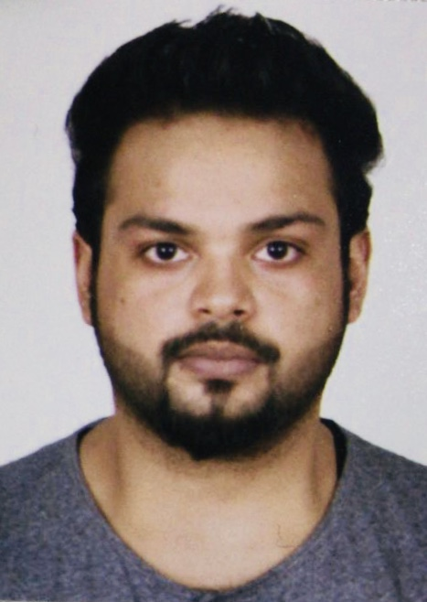
Mr.ESSAM ABDUL SALAM.

Flat no. # 11, blding no. # 1588, road # 2928, Hajjiyat, East Riffa.
P.O.Box 393,Manama, Kingdom Of Bahrain.
Email: essamalqadhi@gmail.com
Mob: 00973 33231923

.

PERSONAL OBJECTIVE

To obtain a responsible and challenging position that will utilize my education, experience, to expand my knowledge, to explore other opportunities for my professional growth

EDUCATIONAL QUALIFICATION

Secondary
Institution: Globals Institute of management and science
Board: British syllabus
Year of passing: 2006

Primary
Institution: Al-Noor International School
Board: British Syllabus
Year of passing: 2004

PROFESSIONAL EXPERIENCE

- Business Development Manager
M/S Al Pesto Café & Restaurant, Riffa, Bahrain,
Period: June01, 2010 –June 31, 2012

- Operation Manager
M/S Al Qadhi Travel & Tourism, Manama, Bahrain.
Period : July 01, 2012- November 31 2014

- Administration Manager
M/S Arad Dental Center WLL
M/S Al Hamad Dental Clinic
Period : December 01, 2014 - Still Contd ……

SKILLS & COMPETENCY

- Computer skills

- Ms word
- Professional e-mailing
- Ms excel

- Administrative skills

- Experience in general office procedure
- Deals with administrative issues
- Good team player and leader
- Accurate data entry
- Good communication skills

ACCOMPLISHMENT AND STRENGTH

- Having good knowledge in Bahrain’s geography and business environment
- Excellent communication, interpersonal and team skills.
- Ability to work reliably and responsibly with initiative and drive, even in a pressurized environment in order to meet deadlines and achieve targets.

PERSONAL INFORMATION

Date of Birth : 13.11.1988
Gender : Male
Nationality : Bahraini
Languages Known : English, Arabic, Hindi.

REFERENCES:

Excellent references will be available as per request

DECLARATION

I hereby declare that the above information are true and correct to the best of my knowledge and belief.

Ar-Riffa, Bahrain Essam Abdul Salam

