A M I R 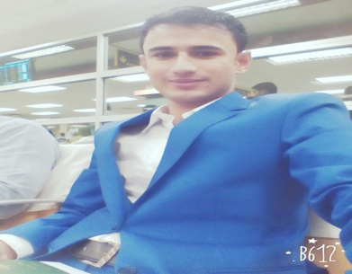
J A L A L
+97335117140
Email Address: burn2@live.com
PROFILE

I want to work in challenging environment to utilize my skills and efforts to make your organization successful.

WORK EXPERIENCE

2017-18 | First reeptionist

- I have One Year experience of Receptionist at Restaurent motel

2016 GDS Galileo Air Line Ticket Reservations

- I have One Year experience of GDS and Galileo Air line ticket Reservations.

2015 Manager Horizon Builders And Communication

- I have One year experience of Manager at Horizon Builders and Communications.

2009-14 Supervisor Canada Calling centre

- I have Five Year experience of Call Centre. It was about handling outbound calls.

EDUCATION

2013 I.com
Federal Board

2008 Matric
Bio,Sci,Phy,Maths

SKILLS
- Leadership communication self motivation

