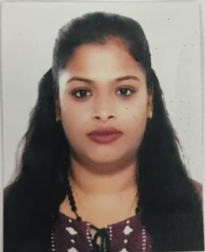
Daphene D. D’souza

MAILING ADDRESS:

Flat 25,Building 56, Road number 716,Block 307.

Email: daphene.dsouza.08@gmail.com

Mobile: +973-33826215

Professional Summary

Responsible trained teacher with excellent communication and co-ordination skills demonstrated by FIVE years of classroom experience. Caring and professional with tireless commitment to student learning and overall well being.

EXPERIENCE
- 16th June 2014 to – 31st December 2019

St. Judes High School- Jeri Meri Mumbai
- Enforce rules for behaviour and procedures for maintaining order among a class of 70 Students.
- Prepare and implement curriculum and liaise with co-teachers for exchanges of ideas and material.
- Distribute teaching material and monitor educational progress for the children.
- Implement an after school tutoring program for children who are falling behind in class.
- Collaborated with classroom teachers to keep activities running on schedule.
- Continued interactions with the students.
- 01Developed a good rapport with children in order to cultivate a safe an encouraging class room atmosphere.
- Maintained safe, positive learning environment.

EDUCATIONAL QUALIFICATIONS
Course and Date | Institute | BOARD | GRADE
T.Y.B.A (Grade 15)  Degree | MUMBAI UNIVERSITY | MUMBAI | B
HSC(Grade 12) | ST.XAVIER’S JR.COLLEGE | MUMBAI | B
SSC (Grade 10) | OUR LADY OF HEALTH | MUMBAI | B

TEACHING DIPLOMA
Course and Date | Institute | BOARD | GRADE
D.T.ED | ST. THERESA’S INSTITUTION | MUMBAI | B

COMPUTER SKILLS
Zoom & Google Classroom
Spreadsheet : - Microsoft Excel
Presentation : - Microsoft PowerPoint
Word Processing : - Microsoft Word

PERSONAL DETAILS
Date of Birth : - 13-July-1994.
Nationality : - Indian
Visa Status : - Family Visa
Sex : - Female
Marital Status : - Married
Language known : - English, Hindi, Marathi.
Hobbies : - Travelling

Declaration
I Daphene D’souza hereby declare that all information given above is correct to the best of my knowledge.
Date:-
Place:-

