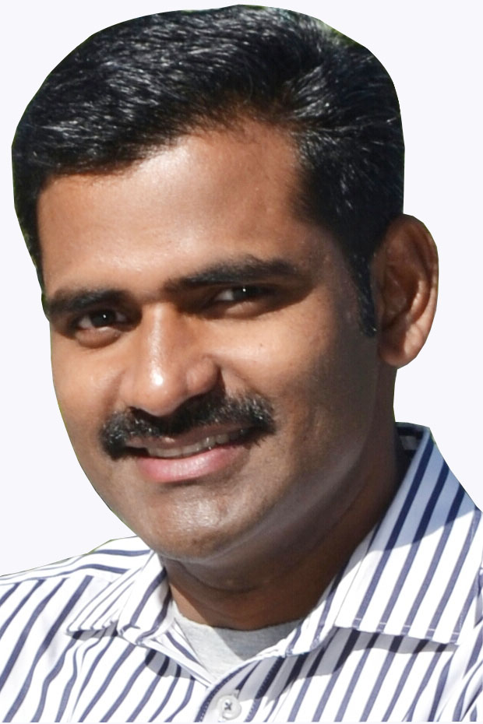
ROJI PAULOSE
Manama
Bahrain
rojipaulose@gmail.com
linkedin.com/in/roji-paulose-b7981714
+973 38771814

I am highly self-motivated and goal-oriented professional committed to pursuing a long-term career in hospitality industry. Offer a 18 years track record demonstrating with strong skills in culinary culture and ability to acquire new skills and knowledge. Independent and passion driven to provide my expertise using modern concepts and creating new experiences in food and drinks by focusing on customer needs and associate development. An open minded individual with a flexible approach to work. Willing to take any responsibilities and assignments regardless of the challenge. Organized and can work under pressure in a busy and multinational environment.

Professional Experience:

Pre & Post Opening Head chef at Café coco Bahrain (A premium dining brand under M.H Alshaya group of company) 15th FEB 2018 – 30TH JUN 2020.
DUTIES & RESPONSIBILITIES:
- Work together with interior team to Setting up kitchen
- Requiting BOH team
- Preparing kitchen SOP with support of administration team
- Control daily kitchen operation, Communicate & coordinate with management and junior staff
- Conducting training program for new joiners ( practical and theoretical ) restaurant & kitchen staff (About new menu/weekly & monthly Special menu / monthly growing program)
- Sample product checking and choosing right product from supplier.
- Order the right food stock and right quantity.
- Enforce and maintain high standards of hygiene.
- Supervise the cooking of food.
- Multi-task and manage several different tasks at the same time.
- Check food deliveries when they arrive to make sure they are up to standard.
- Accurately document revenue and expenditure.
- Update staff timesheets and payroll documents.
- Monitor and control the use of store items on a daily basis.
- Controlling food cost, Labor & chemical cost, supporting cost controller.
- Assist in creating new menu items for future locations complying budget guidelines.
- Taking care of weekly inventory, period and quarterly inventory.
- Highly maintaining food quality & presentation as per the company
Standard.

September 2015 – November 2017. FAUCHON PARIS KUWAIT.

“Sous Chef” in Fauchon Paris Kuwait,(under Gourmania International).
DUTIES & RESPONSIBILITIES:
- Direct reporting to executive chef
- Control daily kitchen operation, Communicate & coordinate with junior staff
- Conducting training program for restaurant & kitchen staff (About new menu/weekly & monthly Special menu/monthly growing program)
- Monitor and control the use of store items on a daily basis.
- Controlling food cost, Labor & chemical cost, supporting cost controller.
- Following the HACCP Standard & giving proper training to the juniors.
- Organizing duty schedule as per business requirements.
- Supporting in production kitchen.
- Work with executive chef to locate issues and offer solutions to implement at multiple locations.
- Assist in creating new menu items for future locations complying budget guidelines.
- Developed employee incentive program to raise employee retention to 90%
- Highly maintaining food quality & presentation as per the company
standard.

- Managed 4 Outlets and Central kitchen (Fauchon Gourmet, Fauchon Avenues, Fauchon 360 and Hot Dawg) during the absence of Executive Chef, which includes coordination of Operations, Administration, Purchase, Cost Controlling, Budgeting, Duty Scheduling, liaising with Head Office. During this tenure, I achieved less F&D Cost with minimum manpower, expense and wastage.

September 2013 – August 2015. RADISSON BLU HOTEL KUWIT.
Worked as a Pre & Post opening team as a Jr. Sous chef at Radisson BLU Hotel Kuwait (Carlson Rezidor Hotel Groups) and in charge of “Al Bustan all-day dining restaurant and Kontiki club house.
Duties & Responsibilities:

- Direct reporting to executive chef.
- Take caring Al-Hashemi functions (the Al-Hashemi hosts a grand ballroom and foyer spread across 1,200 square meters and is furnished with a lavish, gold-leaf wooden interior ideal for up to 1,000 guests).
- Control daily kitchen operation, Communicate & coordinate with junior staff.
- Conducting training program for restaurant & kitchen staff (About new menu/weekly & monthly Special menu/monthly growing program)
- Monitor and control the use of store items on a daily basis.
- Following the HACCP Standard & giving proper training to the juniors.
- Organizing duty schedule as per business requirements.
- Supporting to production kitchen.
- Worked with executive chef to locate issues and offer solutions to implement at multiple locations.
- Assisted in creating new menu items for future locations complying budget guidelines.
- Highly maintaining food quality & presentation as per the company
standard.

December 2009 - August 2013. CROWNE PLAZA HOTEL KUWAIT

Worked as a Pre & Post Opening “Chef de partie” in Crowne plaza Hotel Kuwait (InterContinental hotels groups). As a second in charge in “FAUCHON Paris” outlet.
Responsibilities:
- Direct reporting to senior sous chef.
- Control daily kitchen operation.
- Communicate & coordinate with junior staff.
- Monitor and control the use of store items on a monthly basis.
- Following the HACCP Standard & giving proper training to the juniors.
- Organizing duty schedule as per business requirements.
- Maintaining food quality & presentation as per the company
Standard.

September 2004 - December 2009. RADISSON BLU HOTEL KUWIT.

Worked in AL-BOOM Stake and Sea food Restaurant & Al-Ghazeer Dhow in Radisson Blu Hotel, Kuwait.
Responsibilities:
- Direct reporting to sous chef.
- Control daily kitchen operation.
- Communicate & coordinate with junior staff.
- Giving instruction for preparing full salad bar & condiments.
- Monitor and control the use of store items on a monthly basis.
- Controlling food cost.
- Following the HACCP Standard & giving proper training to the juniors.
- Barbeque in AL-Ghazeer trip.
- Started as a second commi in Garde manger and promoted as first commi. Later on got a position as In-charge of Al-Boom Restaurant.
Other Experience.

- Chef at KTDC (Kerala Tourism Development Corporation), Kerala, India (September 2003 to September 2004)
- Chef at Nadan Plaza, Kottarakara, Kerala, India
- Chef at Manapuram Hotels pvt ltd Trissur, Kerala, India.

Professional Expertise.
- Garde Manger.
- Grill Chef (Barbeque, Steak, Seafood).
- French Cuisine.
- Assist large Banquet Functions.
- Onsite/Live Cooking.
- Food Cost Assessment.
- Budgeting.
- Determining portions
- Menu planning
- Monitoring kitchen staff
- Training employees.
- Manage food inventories.

Professional Achievement
- 1st prize (Gold winner) in HORECA live meat competition 2015.
- 1st prize winner in Food Competitions at Lulu Mall.

Professional Qualification:
Food production (Cookery) FCI Kalamassery, Kerala, India.

Professional Training:
- Basic Food Safety (BFS) from M.H Alshaya
- Person in Charge (PIC) : Level 3 from M.H Alshaya
- Financial Awareness course passed 98.6% from M.H Alshaya
- Safety School - Kitchen Safety from M.H Alshaya
- Managing Aggression through HEART from M.H Alshaya
  - Yes I Can delivering the promise, training for leadership and self-motivation From Radisson BLU Kuwait
- HACCP (Basic Training) From Radisson BLU Kuwait
- Fire Fighting training From Radisson BLU Kuwait
- CPR AED training from Gulf CPR Training Institute (American Heart Association)
- 6 Months training at Mascot hotel, Trivandarum, Kerala, India.

Appreciation Certificates:
- Chaine des Rostisseurs (two times): appreciation certificate from the performance in chaine des rostisseurs dinner.
- Lulu Hypermarket: appreciation certificate for achieving first position in food competion.
- Kuwait University College of engineering & petroleum: appreciation certificate for the performance in college annual reception.
Education:
- Bachelor Degree in Commerce (B.Com) Completed, from Mahatma Gandhi University, Kerala, India.
Personal Information:

- Marital Status : Married.
- Date of Birth : 15-03-1982

Reference:

David Harnois,
Area Executive Chef Middle East
The Rezidor Hotel Group
david.harnois@carlsonrezidor.com
david.harnois@radissonblu.com
# +965 66445271

Stephane Guilbaud
Cooperate Brand Executive Chef
Veranda & Café Coco
Food Division Alshaya Group
Steph.a.guilbaud@gmail.com
# +447899877304

Declaration:
I hereby declare that the above information is true to my best knowledge.

Roji Paulose Date: 1st June 2020

