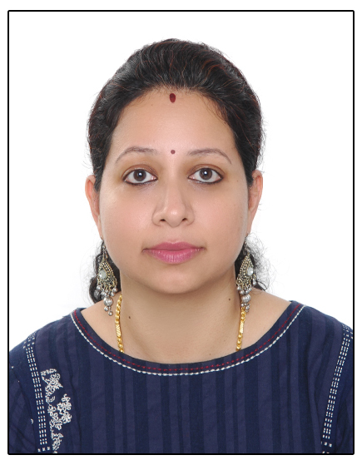

RASHMI NAIR

Mob: 973 38464301
Email: ra_sh_mii@yahoo.in

Objective

Keen to learn and come up to the expectations of tomorrow’s requirements. To grow consistently along with the organisation.

Education Qualification

- Post Graduate with M. Com from Barkatullah University, Bhopal (2002), India.
- Graduate with B. Com from Barkatullah University, Bhopal (2000), India
- XIIth from CBSE (1997)
- Xth from CBSE (1995)

Professional Qualification

- Diploma in Modern Office Management from Sardar Vallabhbhai Polytechnic Bhopal (2000), India.

Experience

Worked with Army Welfare Housing Organisation, Ministry of Defence, New Delhi, India from 2007 to 2019

From 2014 to 2019 as Supervisor CRM Cell (Email)

Responsibilities

- Handling all incoming & outgoing emails.
- Reply to general queries of applicants/ allottees.
- Overall supervision of subordinate staff.
- Screening telephone calls & enquiries by email and directing the team as appropriate.
- Ensure satisfactory resolution to customer queries, request and complaints.
- Typing documents and compiling data for meetings & conferences.
- Making reports on monthly basis and as & when required.

- Making presentations for meetings & conferences.
- Interaction with Project directors for seeking progress of projects.
- Interaction with applicants/ allottees as and when required.
- To monitor the emails sent to various sections and issuing reminders to close the pending issues.
- Coordinating with different departments to resolve issues, if any, for smooth functioning of CRM Cell.
- Taking data & email backup on regular intervals.

From 2007 to 2014 as Clerk-cum-Receptionist

- Handled EPABX and attended footfalls.
- Handled inward and outward correspondence including post, email and fax.
- Attended telecalls and diverted to concerned sections if required.
- Handled official exigencies, bank officials in absence of superior staff.
- Prepared Gate passes for the visitors.
- Fixing the appointments.
- Took shorthand dictations and prepared letters accordingly.
- Dealt with General Correspondence, Bank letters, etc.
- Carried out routine administrative duties like photocopying, scanning, filing etc.
- Data entry work.
- Updated the website on fortnightly basis.
- Coordinated with other sections to answer queries.
- Advise allottees on phone regarding loan issues and mortgage procedures.
- Interacted with loaning agencies to study/ analyses various housing loan schemes offered by them.
- Maintained sale proceeds of application forms.
- Scanning and editing documents & pictures for presentations.
- Maintained all the relevant files and record keeping.

Soft Skills

- Microsoft Word
- Microsoft Excel
- Microsoft PowerPoint
- Microsoft Outlook
- Microsoft Picture Manager
- Knowledge of working in Oracle package

Past Experiences

- National Rural Roads Development Agency (NRRDA), an agency under the Ministry of Rural Roads Development at New Delhi for execution of Pradhan Mantri Gram Sadak Yojna - Worked as Office Assistant from Nov 2004 to Apr 2005.

- Madhya Pradesh Rural Roads Development Agency (MPRRDA), a nodal agency of NRRDA - Worked as Data Entry Operator from Jan 2002 to Apr 2004.

- Central Bureau of Investigation, Char Imli, Bhopal - Worked as Lower Division Clerk on ad-hoc basis from Dec 2000 to Dec 2001.

Strength

Quick learner, laborious, excellent communication skills with proven abilities in customer relationship management & team management.

Personal Profile

Name : Rashmi Nair
Nationality : Indian
Date of Birth : 11th July 1979
Passport Number : S5514235
Place of Issue : Delhi
Date of Issue : 09/10/2018
Date of Expiry : 08/10/2028
Spouse Name : Rajesh S Nair
Languages Known : Hindi, English & Malayalam

References

Col Anil PS, Ex Dir (Land), AWHO : 918284044226
Col Rajbir Singh, Ex Secretary, AWHO : 917891550000

