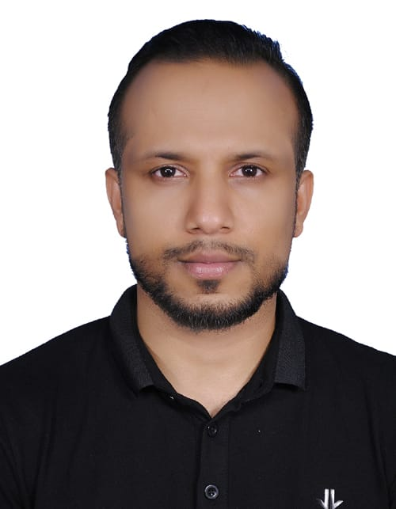

MUSTHAK AHAMMED N.K.
Manama Bahrain.
Mobile: 00973-33103099
Email:musthu080@gmail.com.

OBJECTIVE:

A suitable position in accordance with my knowledge and experience with opportunities for the professional growth and advancement.

KEY SKILLS :

- Quick decision.
- Accuracy.
- Hard working.
- Customer Service.
- Listener.

EDUCATIONAL QUALIFICATION:

- IATA/UFTAA Foundation and EBT Course from Christ College, Bangalore, India.
- B.A TRAVEL & TOURISM MANAGEMENT from University of Kannur, India.
  - Tourism Principle and Practices.
  - Tour Operation
  - Tourism Marketing.
  - Hospitality Management.
  - Travel agency Training.
- Holding valid BAHRAIN DRIVING LICENSE. (5 years experience)

WORK EXPERIENCE AND TRAINING:

Travel Co-ordinator.
Alhind Tours and Travels , Kerala. India . (May-Aug 2009)
Alhind Tours and Travels , Manama. Bahrain. (Jul-)
Responsibilities :
- Reservation and Ticketing (Galileo,Sabre), Online Ticketing.
- Tour operation.
- Attending to customer queries.

Computer operator. (Sep 2009-Mar 2010)
Terbytes computers, Manama Bahrain.

Computer Instructor (Jun 2008-Apr 2009)
Rashid Education Centre, Kasaragod,Kerala,Inida.

Service Co-originator cum Customer support. (Mar 2011- till date)
196 Telcom.
Gosi Complex
Manama Bahrain.

- Organizing and coordinating service jobs.
- Attending calls and customer queries.
- Documentation of invoice, payments.
- Daily reporting and par time programming.

SOFTWARE SKILL & EXPERIENCE

MS-Office
[Ms-Word, Excel, Power Point]
Typing-ENGLISH and ARABIC
Very good at computer.

PERSONAL PROFILE:

Date of Birth : 07th feb 1985.
Nationality : Indian.
Religion : Islam.
Sex : Male.
Blood Group : O +ve.
Height : 165 Cm.
Weight : 68 Kg.
Marital Status : Single.
Passport Details : Passport No.R8319466.
Exp date.02.01.2028.
Issued in Manama Bahrain.
CPR & LICENSE NO. : 850232104

Hobbies : Traveling, Playing Cricket and Listening Music
Languages Known : English, Hindi, Malayalam, Tamil & Arabic.

DECLARATION:

I here by assure that the above details furnished by me are true to my knowledge.

Date:
Place: Musthak Ahammed NK

