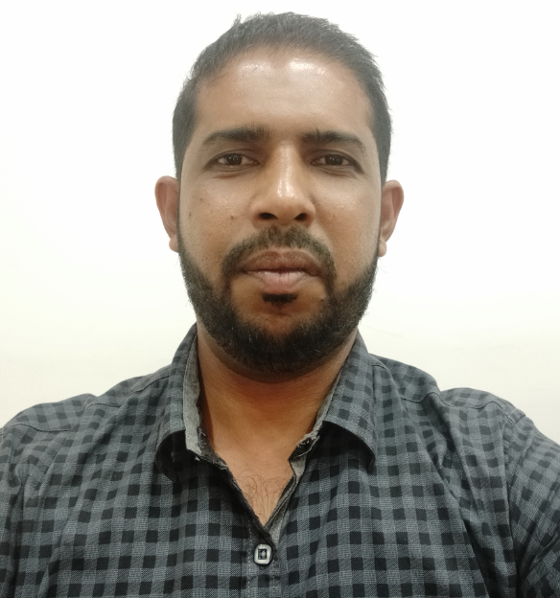
WAYNE BERNARD FERNANDES
E-Mail: waynefdes@gmail.com | Phone: +973 66338280

“Acknowledged for supervising entire aspects of Plant Engineering | Production | Supply Chain Management majorly in Manufacturing industries with strong technology vision, deliverables & functional teams to support business and ensure achievement of committed service levels by optimizing utilization of resources, time & money of the organization”

Location Preference: Gulf Countries

Key Skills  Predictive & Preventive Maintenance  Facility Maintenance  Machine & Manpower Efficiency  Breakdown Maintenance  Production Planning  AutoCAD Drawing  Spare Part Planning  Vendor Management  Capex Budgeting & Execution  Risk Management  Process Engineering  Condition Monitoring |  | Profile Summary  - A competent professional with nearly 15 years of experience in various projects encompassing planning, scheduling, finalization of schedules and progress monitoring of maintenance activities for improving overall reliability and safety of plant equipment & Infrastructure  - Planned & implemented preventive, predictive & breakdown maintenance of Utility Services i.e. Compressors, Generator, Vacuum Pumps, Autoclave, Filament Winding Machines, Pultrusion Machines, Routers, Dust, Collectors, Paint Booths, Trimming Booths, EOT Cranes, Oven and LT Control Panel  - Resourceful in preparing ISO 9001-2015 & IRIS Documents and having experience in SAP and ERP.  - Proficient in identifying & resolving problems, ramping up projects with on time deliverables & maximizing productivity.  - Exceptional in increasing machine uptime & equipment reliability by planning maintenance schedules and conducting periodic checks with increased MTBF & reduced MTTR  - Expertise in managing project activities to facilitate timely completion as per the project schedule, enhance productivity and reduce cost  - Experienced in handling Infrastructure Maintenance  - Excellent in defining & implementing quality standards, structured processes & internal control plans for manufacturing operations of equipment & machines  - Well versed with the EHS standards and procedures  - An effective communicator with excellent relationship building, strong analytical and problem-solving skills

Organizational Experience

Apr’20 –Till Date: Caesars Express, Bahrain as Facility Maintenance Engineer

Key Result Areas
- Preparing predictive & preventive maintenance plans for various Kitchen equipment
- Executing maintenance schedules by conducting periodic checks of all the equipment
- Identifying areas of bottlenecks / breakdowns and taking steps to rectify through application of troubleshooting tools like root cause analysis
- Taking care of maintenance of all the utilities
- Planning and procurement of spares
- Maintaining maintenance reports
- Maintenance of the overall Infrastructure
- Maintaining asset register
- Periodic Testing and Temperature mapping of Ovens

Sep’09 – Dec’19: Kineco Pvt. Ltd., Goa as Sr. Manager – Maintenance

Key Result Areas
- Preparing predictive & preventive maintenance plans for various utilities such as Compressors, Generator, Vacuum Pumps, Autoclave, Filament Winding Machines, Pultrusion Machines, Routers, Dust Collectors, Paint Booths, Trimming Booths, EOT Cranes, Oven, LT Control Panel and their AMCs to increase machine uptime & equipment reliability
- Implementing maintenance schedules and conducting periodic checks to ensure performance and maintaining requisite documents for the same
- Identifying areas of bottlenecks / breakdowns and taking steps to rectify through application of troubleshooting tools like root cause analysis, MTTR, MTBF
- Providing technical support for maintenance to ensure smooth operations and eliminate repeated faults/repairs
- Installation & commissioning activities to ensure completion of project within the time & cost parameters and effective resource utilization to maximize the output
- Ensuring protection tests/ equipment changeovers are conducted in accordance with their schedules; performing cost effective diagnosis and repair of plant and equipment malfunctions
- Ensuring statutory tests and calibration for equipment’s are done periodically
- Coordinating for material/spare parts planning related activities encompassing indenting, spare part specification, keeping inventory of spare parts, identification of vendors, technical evaluation and commercial negotiation.
- Maintaining maintenance records as per ISO 9001-2015 and ISO/TS 22163:2017
- Implementation of ERP and SAP for the Maintenance Department
- Formulating maintenance budget for the financial year and monitoring monthly maintenance costs
- Facilitating plant Infrastructure expansion projects
- Preparing capex budgets and ensuring execution as per the Capex plan, Preparing AutoCAD Drawings.
- Planning, preparing BOQ, selection of vendors, commercial negotiations and executing as per plan; Executed Civil & Fabrication works like Masonry, VDF flooring, Wall & Floor Tiling, Laying of pavers, Bitumen road, Epoxy floor coating, Drain gutters, Construction of soak pit, Septic tank and Water tank, Aluminium partition, UPVC partition, POP partition, False ceiling, Painting, Storage racks, ACP cladding, Construction of shed Structures, Fabrication of MS compressed air lines, lines, vacuum lines, Fabrication of enclosures, trolleys and stands, execution of Landscape works
- Executing all electrical works such as Installation of Transformer, Control panel, Earth pits, Lightening arrestor, DB’s, Cabling, Cable trays and Shop floor Lighting
- Accountable for selecting new machines, finalizing specification and installation. Procured machines namely Filament winding machine, Pultrusion machine, Gelcoat booth, Trimming booth, Painting booth, Dust collectors, Router, Air compressors, Air driers, DG, Vacuum pump, Resin transfer machines, Machining machines, Hand tools, Weighing balances, ACs, Muffle furnace, Cold room, Hydro test facility, Oven, Forklift, Scissors Lift,
- Managing office works like Carpentry, Furniture & Chairs, Plumbing Works, Blinds & Glass Filming and Electrification
- Ensuring refurbishment of old machines
- Adhering to EHS standards and Procedures by implementing safe working practices and permit to work systems
- Installed Firefighting System which includes Fire Hydrant system, Smoke detectors, MCP, Fire Extinguishers
- Contributing as team member for defense projects for the Indian Army and Navy; functioning as a part of Research & Development for an important outsourced product to the Indian Defense as a part of Make in India Project
- Ensuring implementation of Lean Manufacturing & 5S
- Imparting training to the subordinates

Significant Accomplishments
- Reduced Machine downtime by less than 3% through measures such as preventive maintenance, predictive maintenance, finding root cause of breakdown by using statistical quality tools, analysing the risks and inventory management of critical spares
- Successfully executed plant expansion / modification / upgradation projects: set-up a complete 7000 sq. mt. manufacturing unit which includes infrastructure, Plant Utilities and Production Machinery, Beautification of external areas
- Executed works for setting-up of 3 offices
- Set up facilities which covered procurement and installation of new machines and facility for the Indian Defence jobs

Nov’07 – Aug’09: Vicco Laboratories, Goa as Production and Maintenance Engineer

Key Result Areas
- Planned preventive maintenance, breakdown maintenance and everyday production activities
- Managed plant utilities like Boilers, Compressors, Air Drier, Paste & Cream Mixers, Centrifugal pumps, Chilling plant, AHU, Powder and Paste Filling machines, Vacuum pumps, Generator, LT Control Panel & so on
- Upgraded technicians’ skills & approach for increasing uptime of machines and improving manufacturing efficiency
- Led overall operations with a view to ensure timely accomplishment of production targets within the time & cost parameters
- Developed new process concepts for production optimization & yield improvement and developed guidelines for sequencing of manufacturing activities in the organization

Nov’05 – Oct’07: Total Packaging (Sub-Contractor for Godrej Sara Lee Ltd.), Goa as Production Manager

Key Result Areas
- Planned daily production as per the order and ensured preventive maintenance to minimize breakdown
- Managed plant utilities such as Compressor, Generator, Cooling Tower, Oven & Mosquito coil manufacturing machine, packaging lines & so on
- Facilitated manpower allocation by preparing shift schedules
- Conducted analysis of production downtime and recommended preventive measures
- Generated production reports and calculated production cost
- Supervised RM/PM purchases and stores activities for 6 months
- Ensured implementation of GMP and ISO 9001-2000

Previous Experience

Oct’04 – Oct’05: Shiv Samarth Motors (India) Pvt. Ltd., Goa as Service Engineer

Academic Details

- B.E. in Mechanical Engineering from Padre Conceicao College of Engineering Verna, Goa University in 2004

Courses & Certification

- Completed Course in Disaster Management with Advanced Emergency Response Principles through Institute of Health Safety & Environment Council

- Completed Course in Applied Principles of Safety Management Systems through Institute of Health Safety & Environment Council

Personal Details

Date of Birth: 11th May 1982
Permanent Address: H.NO. 1185, Panth Carona Aldona Bardez Goa. 403523
Languages Known: English, Konkani and Hindi
Nationality: Indian
Passport Details: Passport no: M3023225; DOI-17/10/2014; DOE-16/10/2024
Work Visa No: 12019326 Expiry date: 10-05-2021
CPR No: 821502654
Marital Status: Married
No. of Dependents: 1
Notice Period: 1-2 Weeks
Driving License Details: GA03 20190003148 valid 10/05/2032 (Indian)
Temporary Address: Flat No 13, Building 18, Road 801, Block 301, Gudaibiya Bahrain.

