Rafia Alkobaisi
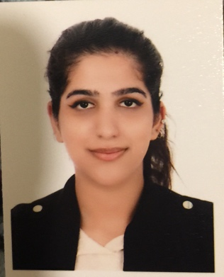
Tel:(+973)-33529851, E-mail:rafiahashel@gmail.com
Saar, Bahrain

Personal Profile

To enhance my educational and professional skills in a stable and dynamic work place.
To build a long term career in Hospitality with opportunity of career growth.

Education

July 2018 – present Diploma in Hospitality and Tourism Management
Bahrain institute of hospitality and retail

2015-2016 The Westminster School ,GEMS Education Dubai, UAE
International general certification in secondary education

Experience

July 2019 Present
Chef commi 3- Wyndham Grand Manama
- Interact with guests on daily basis
- Come up with unique ideas in food and beverage industry
- Achieve the best outcome
- Provide creative dishes

Apr 2017- Dec 2017
Customer Service Representative- Etisalat

- Confer with customers by telephone or in person to provide information about products or services, take or enter orders, cancel accounts, or obtain details of complaints.

- Keep records of customer interactions or transactions, recording details of inquiries, complaints, or comments, as well as actions taken.

- Check to ensure that appropriate changes were made to resolve customer problems.

Jan2016-Mar2017
Receptionist – Umniah real estate

- Ensuring all the work is processed on time

- Dealing with potential clients politely and engaging well

- Provide excess aid to all customers and resolve all issue

- Handle situation with great manner

Oct2017-Feb2018
Hostess-WIEF
- Aid guest with the event information and greet them.
- Hand out the brochure and event catalogue.

Apr2017-Jan2018
Trained by celebrity chef-Capital club, 2 Michelin starred chef Paco rencero

- Learn new recipes
- Develop unique skills and creativity
- Adapt ideas about different cultural cuisine
- Learn new cooking skills according to the origin

January-2019
- Certificate of attending “Chef Services”
with Celebrity Chef ‘Paco Roncero’
at Capital Club Manama - Bahrain

October-2018
- Certificate of attending “Chef Services Italian Cuisine”
With Celebrity Chef ‘Daniel Galmiche’
At Capital Club, Manama –Bahrain

April – 2018
- Certificate of Attending“Contemporary British Cuisine”
With Celebrity Chef Adam Byatt
at Capital Club, Manama -Bahrain.

STRENGTHS

- Adaptability
- Handling pressure
- Critical thinking
- CustomerSatisfaction
- Communication
- Multitasking
- Self-motivation
- Work under pressure
- Problem solving
- Foreign language.

LANGUAGES

- English

- Arabic

- Urdu

Personal Information

- Nationality : Bahraini
- Marital status : Single
- CPR No. : 971013250

References

Dr Sheryl Viegas
Program leader
Bahrain Institute of Hospitality and Retail
Email: Sheryl.viegas@bihr.com.bh

Mr. Godofredo Rojo
Assistant Professor
Bahrain Institute of Hospitality and Retail
Email: Rojo.godofredo@bihr.com.bh

