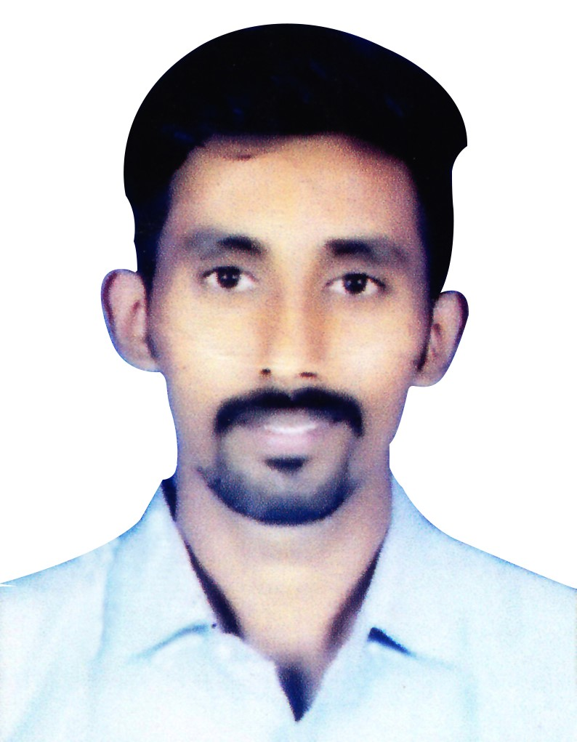
akshay parakkal
email: akshay.parakkal91@gmail.com
Mobile : +973 35067218
Mobile : +91 9004708669

Project and Estimation Engineer with 6 years of Experience in the field of Oil & Gas, Pharmaceutical and Chemical Sector.

I am looking forward to join your esteemed company and to be a part of your successful team achieving the targets and pursuing a challenging career, with a view to excel by hard work enhancing the quality of work assigned to me in the best of my capacity to grow professionally.

Educational Qualifications:

Sr. No | Qualification | Name of Institute | Board / University | Year of Passing | Percentage
1. | PGD Piping Engineering. | Maharashtra Institute of Technology. | Pune University | 2014 | 60%
2. | B.E MECH | Viva Institute of Technology | University of Mumbai | 2013 | 59.2 %
3. | HSC | Vivek Vidhyala Jr. College of Science | Maharashtra Board | 2009 | 65.33 %
4. | SSC | St. Anthony’s High School | Maharashtra Board | 2007 | 78.30 %

Work Experience:

- Organization name : HAJI HASSAN GROUP.
- Designation : Project & Estimation Engineer.
- Duration : January 2019 to Present.
- Job Responsibility
- Project Cost Estimation
- Material Extraction
- Material Procurement
- Preparation of Job Cards
- Opening and Closing Jobs
- Preparing Material Requisitions
- Negotiating with vendors and suppliers
- Tendering, E-Tendering
- Project Co-ordination
- Floating Enquiries to various vendors for Materials
- Preparation of Bill of Materials (BOM).
- Reading Structural, Mechanical and Piping Fabrication Drawings to calculate BOQ and take necessary actions accordingly.
- Attend Meetings.
- Site Visits.

- Organization name : SUPREME ALLIED SERVICES PVT. LTD.
- Designation : Project Engineer.
- Duration : March 2018 to November 2018.
- Projects Handled : Mechanical and Piping Work (Ineos Styrolution India Ltd.Moxi),
Structural, Mechanical and Piping Work (Glenmark Pharmaceuticals Ltd. Baddi, Himachal Pradesh.),
Structural, Mechanical and Piping Work (Anupam Rasayan Ltd. Gujarat).
Structural, Mechanical and Piping Work (Intas Pharamceuticals Ltd. Gujarat).
Structural, Mechanical and Piping Work (Dr. Reddy’s Lab) Structural, Mechanical and Piping Work (Nirma Ltd, Gujarat)
Structural, Mechanical and Piping Work ( Hindustan Coca-Cola Beverages Pvt. Ltd, Vizag & Ghaziabad)
Structural and Civil works (BGR Realty, Bhiwandi)
Structural, Mechanical and Piping Work ( Roquette Riddhi Siddhi Pvt Ltd.)

- Job Responsibility
- Tendering, E-Tendering
- Project Co-ordination with ongoing Sites and HO.
- Floating Enquiries to various vendors for Pipes, fittings, Valves and Special Items.
- Handling Tenders and Proposals.
- Cost Estimation.
- Preparation of Bill of Materials (BOM).
- Reading Structural, Mechanical and Piping Fabrication Drawings to calculate BOQ and take necessary actions accordingly.
- Look after Purchase and Billing of the materials required on site.
- Attend Meetings.
- Site Visits.

- Organization name : SAGA GLOBAL CONSULTANTS.
- Designation : Project Engineer.
- Duration : October 2015 to March 2018.
- Projects Handled : Automatic Fire Water Sprinkler System (ONGC) ,
Construction of Petroleum Storage Depot at Silchar Assam (IOCL).
Construction of Petroleum Storage Depot at Pali, Rajasthan (EOL).
Oil Terminal at Ghana (Vihama Energy Company Ltd).
- Job Responsibility
- Co-ordination with other Engineering department.
- Preparation of List of Deliverables of every Engineering Department.
- Handling Tenders and Proposals.
- Preparation of Piping Bill of Materials (BOM).
- Preparation of Piping General Arrangement (GA) and Piping Isometric drawings.
- Preparation of Line List.
- Attend Meetings.
- Site Visits.

- Organization name : PARASCADD PVT.LTD.
- Designation : Piping Engineer
- Duration : January 2015 to September 2015.
- Project : Fort Hills Utility Canada, North West Redwater (NWR).
- Job Responsibility
- Co-ordination with planning team on piping work.
- Spool marking on Isometric piping drawings.
- Generating Erection & Spool Drawing with bill of material.
- Generating M.T.O.
- Generating reports of Fit-up, Welding, NDT QA/QC, Pressure test, Painting, Lay down, Dispatch

- Organization name : Precision Machinists.
- Designation : Mechanical & Piping Design Engineer (AutoCAD and Solidworks)
- Duration : July 2014 to December 2014.
- Project : Power Soaps Limited.
- Job Responsibility
- Creating 3D model of soap cutting machine on Solidworks.
- Creating PFD, P&ID for Toilet and Laundry Soap Plant on AutoCAD.
- Equipment Layout as per Client requirement.
- Calculation of Equivalent Lengths of Pipe required.

Computer skills:

Master diploma in Automotive Design, CADD CENTRE Borivali.
- Creo
- Catia
- Nx-Cad
- Nx-Cam
- Nx-Nastran
- Autocad
- Solidworks

Post-Graduation Program in Piping Engineering, MIT Pune.
- Piping Design Management System (PDMS)
- Caesar II

Other Softwares known:
- AutoSpool
- SpoolMan

Technical skills:
- Preparing Bulk MTO & Final MTO from P&ID Isometrics.
- To read isometric drawings with MTO & Supports and work accordingly.
- Familiar with Piping Codes and Standards.
- Able to study piping and equipment layout development and plot plan development.
- Knowledge of process Equipment.
- Knowledge of special parts, Valves, types of fittings.

Strengths:

- Willingness to learn new technologies.
- Like to share the knowledge gained with the team members
- Positive attitude.
- Hard working
- Leadership Qualities

Personal Details:

Date of Birth : 20th December, 1991.
Address : B-18 Jaydeep Apt,Bafhira Nagar,
Marve Road, Malad West,
Mumbai - 400095.
Gender : Male
Marital Status : Unmarried
Languages Known : English, Hindi, Marathi and Malayalam.
Passport No : M3341393
Date of Expiry : 29/10/2024
CPR No : 911247670
Driving License : Valid Bahrain Driving License till 23/02/2025
Skype ID : akshay_p7

Declaration:

I hereby declare that the above-mentioned information is correct, to the best of my knowledge.

Place: Bahrain

akshay parakkal.

